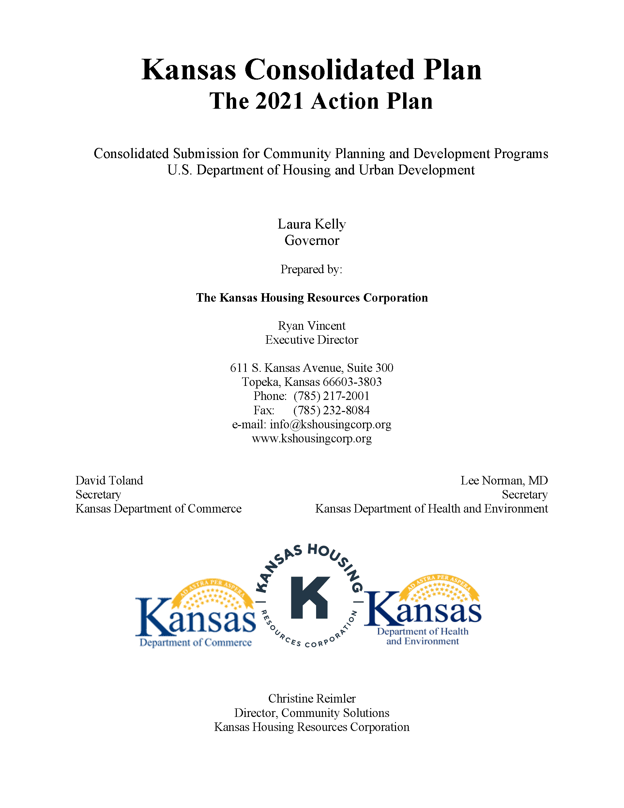

Executive Summary

AP-05 Executive Summary - 24 CFR 91.200(c), 91.220(b)
1. Introduction
The Kansas Consolidated Plan is mandated by the U.S. Department of Housing and Urban Development (HUD). The objectives of the Consolidated Plan, as identified by HUD and accepted by the Kansas Department of Commerce (Commerce), the Kansas Housing Resources Corporation (KHRC), and the Kansas Department of Health and Environment (KDHE), are to:
- Create communities of opportunity
- Foster a comprehensive vision of development
- Promote coordination of local activities
- Establish a continuum of care with homeless persons
- Support economic opportunities for target areas
- Assist low-and-moderate income persons, minority- and women-owned businesses
- Encourage innovative projects
The Kansas Consolidated Plan affirms the three national objectives of Title I of the Housing and Community Development Act of 1974, as amended, including activities which:
- Primarily benefit low-and-moderate income persons
- Aid in the prevention of slums and blight
- Alleviate conditions which pose a serious and immediate threat to the health or welfare of a community
The Kansas Consolidated Plan also endorses the objectives of the National Affordable Housing Act of 1990, which are to:
- Ensure that all residents have access to decent shelter
- Increase the supply of affordable housing
- Make neighborhoods safe and livable; expand opportunities for homeownership
- Provide a reliable supply of mortgage finance
- Reduce generational poverty in assisted housing
The Kansas Consolidated Plan also addresses the needs of persons living with HIV/AIDS.
The Kansas Consolidated Plan supports the objectives of the Stewart B. McKinney Homeless Assistance Act of 1987.
Accordingly, the Kansas Consolidated Plan describes the priorities and guidelines of the four federally funded programs, including: Community Development Block Grant (CDBG) program, HOME Investment Partnerships (HOME) program, Housing Trust Fund (HTF), Emergency Solutions Grant (ESG) program, and Housing Opportunities for Persons with AIDS (HOPWA) program. The Department of Commerce will administer the CDBG program. Kansas Housing Resources Corporation (KHRC) will administer the HOME, HTF, and ESG programs. The Kansas Department of Health and Environment (KDHE) will administer the HOPWA program.
2. Summarize the objectives and outcomes identified in the Plan
This could be a restatement of items or a table listed elsewhere in the plan or a reference to another location. It may also contain any essential items from the housing and homeless needs assessment, the housing market analysis or the strategic plan.
The three overarching objectives guiding the proposed activities are:
- Providing decent affordable housing
- Creating suitable living environments
- Creating economic opportunities
Outcomes show how programs and activities benefit a community or the people served. The three outcomes that will illustrate the benefits of each activity funded by the four federal programs are:
- Improved availability/accessibility
- Improved affordability
- Improved sustainability
All future activities funded under the five-year Consolidated Plan will support at least one objective and one outcome. The framework for realizing the objectives and outcomes include the following goals:
- Provide decent, affordable housing
- Provide a suitable living environment
- Expand economic opportunities
- Increase homeownership
- End chronic homelessness
Kansas Performance Measures are established to monitor the State’s progress on outcomes and objectives for each program. While each program has successfully provided services in the past, these new measures should enhance the State’s ability to quantify the results of those activities and convey a complete picture of housing and community development activities. For FY 2021, the CDBG Program projects 44,000 persons will be provided a suitable living environment, 70 households will have access to decent housing, and 104 persons will be provided an economic opportunity. The ESG Program projects to assist 3,375 households with the availability of a suitable living environment and provide 1,000 decent affordable homes to Kansas families. The HOME Program projects to make 319 decent homes affordable to Kansas families. The HTF will create or rehabilitate 15 units. The HOPWA Program projects to make 500 decent homes affordable to Kansas families living with HIV/AIDS.
3. Evaluation of past performance
This is an evaluation of past performance that helped lead the grantee to choose its goals or projects.
The State of Kansas made progress on its priority needs and objectives in FY 2018, the last complete period for which a Consolidated Annual Performance and Evaluation Report (CAPER) was conducted. The best indicators of results, i.e., performance measures, are described below for the Community Development Division of the Department of Commerce (Commerce), Kansas Housing Resources (KHRC), and Kansas Department of Health and Environment (KDHE).
Community Development Block Grant (CDBG) Program:
The State continues to focus CDBG resources on public water/wastewater infrastructure, community public facilities, housing, and economic development with the express purpose of assisting businesses with job creation. In addition, we have small set-asides for urgent need and downtown commercial rehabilitation projects. The State is on target to obligate all FY19 CDBG funds to local governments carrying out these activities.
HOME Investment Partnerships (HOME) Program:
The State received $5,802,824 million in HOME funds and awarded the same in FY 2019. The HOME Program served 56 households with their First Time Homebuyer Program, TBRA served 621 households, and the Rental Program developed 10 newly constructed and 22 rehabilitated units.
National Housing Trust Fund
The State was allocated $3 million in HTF, awarded the same in FY 2019, and completed 2 new construction units.
Housing Opportunities for Persons with AIDS (HOPWA) Program:
The HOPWA Program provided housing assistance to 201 clients. The program helped 72 of these client’s transition from homelessness into secure housing. Overall, the program reached 376 different individuals, including the family members of the clients who Kansas Care Through Housing (KCTH) served. The HOPWA Program provided supportive services to 556 individuals, which included 378 clients and their family members. The supportive services are crucial to clients outside of just housing assistance, as many areas around the state lack the necessary resources to provide these services.
Emergency Solutions Grant (ESG) Program:
In FY 2019, the KHRC received a total of $1,607,182 in ESG funds. KHRC awarded ESG funds for services in street outreach, emergency shelters, homelessness prevention, rapid re-housing, HMIS, and administrative activities. These activities were targeted to households that were literally homeless or at imminent risk of homelessness with incomes 0-30% of Area Median Family Income (AMFI) and to individuals and families in the following at-risk homeless categories: chronically homeless, HIV/AIDS, elderly, veterans, mental health, youth, domestic violence victims and substance abuse. During FY2019, a total of 2,938 persons. Homelessness prevention served 271 persons, rapid re-housing served 490 persons, emergency shelter assisted 2,1228 persons, and 55 persons in street outreach.

4. Summary of Citizen Participation Process and consultation process
Summary from citizen participation section of plan.
Due to COVID, one needs hearing was held virtually for public input on housing priorities in the 2021 Action Plan. The public hearing was announced through a public notice in the Kansas Register on August 6, 2020, posted on the Kansas Housing Resources Corporation website, and additional e-mail notification. The public input hearing on housing occurred in Topeka, Kansas, on August 18, 2020.
Another virtual public hearing was held on October 1, 2020, for public comment on the preliminary draft of the 2021 Action Plan. The public hearing was announced through a public notice in the Kansas Register on September 17, 2020, posted on the Kansas Housing Resources Corporation website, and additional e-mail notification. The announcement of the public comment hearing included information on where to find the complete document for public examination. The public comment period was October 1, 2020 – October 31, 2020. A summary of citizen comments is provided at the end of the plan.
5. Summary of public comments
This could be a brief narrative summary or reference an attached document from the Citizen Participation section of the Con Plan.

6. Summary of comments or views not accepted and the reasons for not accepting them

7. Summary

PR-05 Lead & Responsible Agencies - 91.300(b)
1. Agency/entity responsible for preparing/administering the Consolidated Plan
The following are the agencies/entities responsible for preparing the Consolidated Plan and those responsible for administration of each grant program and funding source.
Agency Role | Name | Department/Agency

CDBG Administrator | KANSAS | Department of Commerce
HOPWA Administrator |  | Kansas Department of Health and Environment
HOME Administrator | KANSAS | Kansas Housing Resources Corporation HOME Program
ESG Administrator | KANSAS | Kansas Housing Resources Corporation ESG Program
 | KANSAS | Kansas Housing Resources Corporation HTF Program
Table 1 – Responsible Agencies

Narrative
The Consolidated Plan was developed in partnership between the Kansas Department of Commerce (Commerce), Kansas Housing Resources Corporation (KHRC), and the Kansas Department of Health and Environment (KDHE). The table above should include KHRC as Administrator of the Housing Trust Fund (HTF). The strategies defined in the State of Kansas five-year 2019-2023 Consolidated Plan and the 2021 Annual Action Plan are implemented by state agencies, municipalities, non-profits, lenders, and housing developers. These groups are consulted on a regular basis when developing and carrying out the strategies and goals of the Annual Action Plan. The state also requested input from COCs, civic leaders, and public housing agencies.
Kansas Housing Resources Corporation, Kansas Department of Commerce, and the local USDA Rural Development conduct quarterly interagency meetings to plan and review collaborative efforts related to housing. KHRC has also been placed on e-mail/mailing lists for upcoming events held by Kansas African American Affairs Commission and Kansas Hispanic & Latino Affairs Commission.
KHRC also collaborates with the Kansas Department for Aging and Disability Services (disability services) and KDHE (Medicaid) to facilitate the partnerships necessary to effectively utilize the new funding opportunities created under the Frank Melville Supportive Housing Act of 2010. HUD’s Section 811 program, included in the Frank Melville Supportive Housing Act, provides supportive housing opportunities for persons with disabilities. The changes affected in the 2010 reforms to the Section 811 program put added emphasis on community integration, leveraging of other project development resources (such as HOME and Low-Income Housing Tax Credits) and collaboration with State social service and Medicaid agencies to provide necessary services to support disabled individuals in independent living.
Consolidated Plan Public Contact Information
Christine Reimler, Consolidated Plan Coordinator
Kansas Housing Resources Corporation
611 S. Kansas Avenue, Suite 300, Topeka, KS 66603-3803
785.217.2023 creimler@kshousingcorp.org

AP-10 Consultation - 91.110, 91.300(b); 91.315(l)
1. Introduction
The strategies defined in the State of Kansas five-year 2019-2023 Consolidated Plan and the 2021 Annual Action Plan are implemented by state agencies, municipalities, non-profits, lenders, and housing developers. These groups are consulted on a regular basis when developing and carrying out the strategies and goals of the Annual Action Plan. The state also requested input from COCs, civic leaders, and public housing agencies.
Provide a concise summary of the state's activities to enhance coordination between public and assisted housing providers and private and governmental health, mental health and service agencies
Kansas Housing Resources Corporation (KHRC) consulted with local governments and State agencies on the preparation of the 2019-2023 Consolidated Plan and the 2021 Action Plan. KHRC contacted the local Consolidated Plan coordinators of entitlement areas to offer assistance on local Consolidated Plan documents and to invite recommendations on State community development and housing initiatives.
Kansas Housing Resources Corporation, Kansas Department of Commerce, and the local USDA Rural Development conduct quarterly interagency meetings to plan and review collaborative efforts related to housing. KHRC has also been placed on e-mail/mailing lists for upcoming events held by Kansas African American Affairs Commission and Kansas Hispanic & Latino Affairs Commission.
KHRC also collaborates with the Kansas Department for Aging and Disability Services (disability services) and Kansas Department of Health & Environment (KDHE/Medicaid) to facilitate the partnerships necessary to effectively utilize the new funding opportunities created under the Frank Melville Supportive Housing Act of 2010. HUD Section 811 program, included in the Frank Melville Supportive Housing Act, provides supportive housing opportunities for persons with disabilities. The changes affected in the 2010 reforms to the Section 811 program put added emphasis on community integration, leveraging of other project development resources (such as HOME and Low Income Housing Tax Credits) and collaboration with State social service and Medicaid agencies to provide necessary services to support disabled individuals in independent living.
Describe coordination with the Continuum of Care and efforts to address the needs of homeless persons (particularly chronically homeless individuals and families, families with children, veterans, and unaccompanied youth) and persons at risk of homelessness
The State of Kansas supports a Continuum of Care (CoC) approach among State ESG recipients. KHRC collaborates on a recurring basis with the Balance of State CoC and the Johnson County CoC. All funds from the State's ESG funding are made available to the non-ESG entitlement continuums. Continuum of Care components include affordable, accessible, and integrated permanent housing and homeless services that enable individuals and families to reach the maximum degree of self-sufficiency possible. In reviewing ESG applications, the State relies on local units of government to determine what their communities unique homeless needs may be, and how the ESG program can assist with those needs. This approach allows local jurisdictions to determine their own priorities and needs in addressing homelessness in their communities.
Describe consultation with the Continuum(s) of Care that serves the State in determining how to allocate ESG funds, develop performance standards for and evaluate outcomes of projects and activities assisted by ESG funds, and develop funding, policies and procedures for the operation and administration of HMIS
See above description of the coordination and consultation efforts.
KHRC staff who manage the ESG program work closely with the continuum of care staff to administer the program statewide.
2. Agencies, groups, organizations and others who participated in the process and consultations

Table 2 – Agencies, groups, organizations who participated
1 | Agency/Group/Organization | KANSAS DEPARTMENT OF COMMERCE
 | Agency/Group/Organization Type | Other government - State
 | What section of the Plan was addressed by Consultation? | Market Analysis  Anti-poverty Strategy  Lead-based Paint Strategy  CDBG Market Analysis & Strategy
 | Briefly describe how the Agency/Group/Organization was consulted. What are the anticipated outcomes of the consultation or areas for improved coordination? | Consulted through email and phone calls.
2 | Agency/Group/Organization | Kansas Department of Health and Environment
 | Agency/Group/Organization Type | Other government - State
 | What section of the Plan was addressed by Consultation? | Anti-poverty Strategy  HOPWA Needs Assessment
 | Briefly describe how the Agency/Group/Organization was consulted. What are the anticipated outcomes of the consultation or areas for improved coordination? | Consulted through emails and phone calls.
3 | Agency/Group/Organization | UNIVERSITY OF KANSAS SCHOOL OF MEDICINE
 | Agency/Group/Organization Type | University
 | What section of the Plan was addressed by Consultation? | Anti-poverty Strategy  HOPWA Needs Assessment & Strategy
 | Briefly describe how the Agency/Group/Organization was consulted. What are the anticipated outcomes of the consultation or areas for improved coordination? | Consulted through emails and phone calls.
4 | Agency/Group/Organization | Kansas Interagency Council on Homelessness
 | Agency/Group/Organization Type | Other government - State
 | What section of the Plan was addressed by Consultation? | Housing Need Assessment  Homeless Needs - Chronically homeless  Homeless Needs - Families with children  Homelessness Needs - Veterans  Homelessness Needs - Unaccompanied youth  Homelessness Strategy  Anti-poverty Strategy  Homelessness Needs Assessment
 | Briefly describe how the Agency/Group/Organization was consulted. What are the anticipated outcomes of the consultation or areas for improved coordination? | Consulted through emails and phone calls.
5 | Agency/Group/Organization | Kansas Labor Information Center
 | Agency/Group/Organization Type | Other government - State
 | What section of the Plan was addressed by Consultation? | Non-Homeless Special Needs  Market Analysis  Anti-poverty Strategy  Market Analysis and Non-Housing
 | Briefly describe how the Agency/Group/Organization was consulted. What are the anticipated outcomes of the consultation or areas for improved coordination? | Consulted through email and phone calls.
6 | Agency/Group/Organization | KANSAS HOUSING RESOURCES CORPORATION
 | Agency/Group/Organization Type | Other government - State
 | What section of the Plan was addressed by Consultation? | Housing Need Assessment  Public Housing Needs  Homeless Needs - Chronically homeless  Homeless Needs - Families with children  Homelessness Needs - Veterans  Homelessness Needs - Unaccompanied youth  Non-Homeless Special Needs  HOPWA Strategy  Market Analysis  Economic Development  Lead-based Paint Strategy  All sections of the Consolidated Plan
 | Briefly describe how the Agency/Group/Organization was consulted. What are the anticipated outcomes of the consultation or areas for improved coordination? | Consulted through email and phone calls.

Identify any Agency Types not consulted and provide rationale for not consulting
Not applicable.

Other local/regional/state/federal planning efforts considered when preparing the Plan
Name of Plan | Lead Organization | How do the goals of your Strategic Plan overlap with the goals of each plan?
Continuum of Care
State of KS Opening Doors Report | Kansas Interagency Council on Homelessness | Strategic Goal 13 calls for assisting 1,250 homeless persons and providing housing for 3,375 households. The Opening Doors Report connects with this goal as it calls for an end to chronic homelessness and a path for ending all homelessness.
Economic Development Strategy | Office of the Governor | Strategic Goal 5 calls for Economic Development and the creation of 37 jobs and assistance to businesses. One of the Economic Development Strategic Plan goals is the provision of workforce and infrastructure resources towards faster economic growth and job creation.
Table 3 - Other local / regional / federal planning efforts

Narrative
See above description of the coordination and consultation efforts. In addition, there are other entities that are partners in facilitating the development of affordable housing and in implementing portions of the Consolidated Plan. These include the following:
Kansas Development Finance Agency (KDFA)
In addition, the Kansas Development Finance Agency (KDFA) possesses multiple bond financing capabilities for multiple jurisdictions in the state.
For example, the KDFA issues revenue bonds to finance projects of the Kansas Board of Regents and State agencies. The KDFA issues bonds for public and private educational facilities and healthcare facilities. The KDFA issues tax-exempt bonds to make below market interest rate loans to farmers. The KDFA issues private activity bonds to finance agricultural and industrial enterprises, corporate and management offices.
In particular, the KDFA is empowered to exercise all powers granted to public housing authorities by the State. In the past, the KDFA has issued revenue bonds to finance numerous multifamily housing developments in Kansas.
According to KDFA’s Mission Statement, KDFA was “created and dedicated to the economic growth and prosperity of our State, KDFA works with qualifying public and private entities to identify financial resources and appropriate financial structures. For information on capital finance mechanisms available to governmental and qualifying private enterprises, KDFA is a statewide, multipurpose financial resource.”
Community Housing Development Organizations (CHDOs)
Since 1992, approximately 40 non-profit organizations have requested certification as CHDOs in the State of Kansas, although not all are active. Currently, 19 certified CHDOs own and manage HOME-assisted rental housing across the state, and approximately 15 are actively involved in the development of new affordable housing. Altogether, over half of the state’s 105 counties have HOME-assisted rental housing developed by CHDOs. The State has allocated at least 15 percent of HOME funds to CHDO program activities and no more than five percent of HOME funds to CHDO operating expenses.
CHDOs are eligible to apply for HOME funds only for the activity of rental development. CHDOs using HOME funds can leverage those funds with other funding sources such as private mortgages, Tax Credits, Private Activity Bonds, grant funding, etc
Process for Local Government
An application process has been developed by the State for communities to access resources for financial assistance to address both housing and non-housing community development needs. In general, the Kansas Department of Commerce (Department of Commerce), the Kansas Housing Resources Corporation (KHRC), and the Kansas Department of Health and Environment (KDHE) will approve funding for development projects which satisfy one or more of the identified need criteria. The criteria include the following: community need, community effort, resident need, resident risk, and preventive action.

AP-12 Participation - 91.115, 91.300(c)
1. Summary of citizen participation process/Efforts made to broaden citizen participation
Summarize citizen participation process and how it impacted goal-setting

The State of Kansas conducted two virtual public hearings on housing and community development issues to allow citizens to provide input into the 2021 Kansas Annual Action Plan. This is the policy framework for federally-funded community development and housing programs. The public hearings focused on housing and community development needs throughout the State and strategies to address those needs. The notice was also available via download on the Kansas Housing Resources Corporation (KHRC) website at www.kshousingcorp.org.
The virtual needs hearing was announced through a public notice in the Kansas Register on August 6, 2020. The virtual public needs hearing occurred in Topeka on August 18, 2020. A public notice was also published in the Kansas Register on September 17, 2020 for the October 1, 2020 virtual public hearing. The public hearings were designed to encourage participation by local, regional, statewide institutions, Continuum of Care, and other public and private organizations. The public hearing notices included the amount of federal dollars the State anticipated receiving, in addition to encouraging participation by individuals with disabilities or limited English proficiency.

Citizen Participation Outreach
Sort Order | Mode of Outreach | Target of Outreach | Summary of  response/attendance | Summary of  comments received | Summary of comments not accepted and reasons | URL (If applicable)
2 | Public Meeting | Statewide | Virtual Public Needs Hearing held August 18, 2020. | No comments received.
3 | Notice Placed in the Kansas Register | Statewide | Notice Placed in the Kansas register on September 17, announcing the October 1, 2020 virtual Public Hearing. |  |  | https://sos.ks.gov/publications/register/2020/Vol_39_No_38_September_17_2020_pages_1143-1166.pdf
4 | Internet Outreach | Statewide | Email notice sent to partners and stakeholders September 24, 2020, announcing the Public Hearing.
5 | Public Hearing | Statewide | Virtual public hearing held October 1, 2020.
6 | Draft of Plan posted on KHRC website | Statewide | The month of October the draft of the 2020 Annual Action Plan was posted on Kansas Housing Resources Corp. website: www.kshousingcorp.org
Table 4 – Citizen Participation Outreach

Expected Resources

AP-15 Expected Resources – 91.320(c)(1,2)
Introduction
The following table displays the anticipated resources to be allocated to non-entitlement areas of Kansas broken down by program type. The 2021 HUD allocations are reflected in the “Annual Allocation” column below. The “Expected Amount Available Remainder of Con Plan” column is a projection of funds to be available for program years 2022-2023. As with previous Consolidated Plans for the State of Kansas, the “Expected Amount Available Remainder of Con Plan” column is generated by multiplying the annual allocation by two, representing years 4-5 of the Consolidated Plan cycle. The relevant years will be adjusted as allocations are made and more precise assumptions can be made on program income.
Anticipated Resources
Program | Source of Funds | Uses of Funds | Expected Amount Available Year 1 |  |  |  | Expected Amount Available Remainder of ConPlan  $ | Narrative Description
 |  |  | Annual Allocation: $ | Program Income: $ | Prior Year Resources: $ | Total:  $
CDBG | public - federal | Acquisition  Admin and Planning  Economic Development  Housing  Public Improvements  Public Services | 15,368,341 | 350,000 | 3,000,000 | 18,718,341 | 30,736,682 | Kansas requires all CDBG funds to be matched by receiving communities. While not federally required, leveraging CDBG dollars maximizes the benefit to LMI persons.
HOME | public - federal | Acquisition  Homebuyer assistance  Homeowner rehab  Multifamily rental new construction  Multifamily rental rehab  New construction for ownership  TBRA | 6,361,744 | 100,000 | 0 | 6,461,744 | 12,723,488 | The First Time Homebuyers Program and the HOME Rental Program both require a local match.
HOPWA | public - federal | Permanent housing in facilities  Permanent housing placement  Short term or transitional housing facilities  STRMU  Supportive services  TBRA | 606,673 | 0 | 0 | 606,673 | 1,213,346 | Kansas HOPWA funds to be matched by receiving communities, especially through paring funding with local non-profits. While not required by HUD, leveraging HOPWA funds maximizes benefits for persons with aids.
ESG | public - federal | Conversion and rehab for transitional housing  Financial Assistance  Overnight shelter  Rapid re-housing (rental assistance)  Rental Assistance  Services  Transitional housing | 1,648,274 | 0 | 0 | 1,648,274 | 3,296,548 | Kansas ESG funds must be matched dollar-for-dollar by the local recipient. KHRC is awarded these funds annually and makes them available to local units of government of non ESG entitlement communities in Kansas.
HTF | public - federal | Acquisition  Admin and Planning  Homebuyer assistance  Multifamily rental new construction  Multifamily rental rehab  New construction for ownership | 3,000,000 | 0 | 0 | 3,000,000 | 6,000,000 | The Housing Trust Fund does not require matching funds.
Table 1 - Expected Resources – Priority Table

Explain how federal funds will leverage those additional resources (private, state and local funds), including a description of how matching requirements will be satisfied
The State of Kansas makes every attempt to leverage CDBG, HOME, ESG, and HOPWA funds with additional non-federal funding resources. In the past CDBG funds have typically seen a greater than 50% match on most projects, bringing in other federal dollars, state funds, or local government/private funds.
HOME funds leverage private mortgages, grants, other federal programs, bond financing, and tax credits. Match for the HOME Program will be met through a combination of cash from non-federal sources, foregone fees, bond financing, and donated land and labor.
For the Low-Income Housing Tax Credit (LIHTC) program KHRC will collaborate with cities, counties, and regions of the state to determine high need areas for rental housing. The HOME staff and Low-Income Housing Tax Credit staff works closely together to ensure the most efficient use of rental housing funding.
KCTH uses HOPWA funds to collaborate with Shelter Plus Care, Section 8 Housing, LIEPA and other food pantry resources. KCTH also closely collaborates with the Kansas Department of Health and Environment though the STI/HIV Care program and the Ryan White Parts B, C and D programs.

If appropriate, describe publically owned land or property located within the jurisdiction that may be used to address the needs identified in the plan
Not applicable to State Grantee
Discussion
While leveraged funds and support from outside partners broadens the accomplishments of each program, the historical trend of funding reductions significantly impacts the CDBG and HOME programs. Reduced federal funding makes it more difficult to leverage supplemental resources and provide technical assistance on other resource opportunities. Therefore, the federal reductions reduce the amounts that can be leveraged.

Annual Goals and Objectives
AP-20 Annual Goals and Objectives – 91.320(c)(3)&(e)
Goals Summary Information
Sort Order | Goal Name | Start Year | End Year | Category | Geographic Area | Needs Addressed | Funding | Goal Outcome Indicator
1 | Water and Sewer Improvements | 2019 | 2023 | Water and sewer improvements
2 | Increase the quality of affordable housing | 2019 | 2023 | Affordable Housing
3 | Community Facilities | 2019 | 2023 | Community Facility Improvements
4 | Economic Development | 2019 | 2023 | Community Development
5 | Downtown Commercial Redevelopment | 2019 | 2023 | Non-Housing Community Development
6 | Urgent Need | 2019 | 2023 | Affordable Housing  Non-Housing Community Development
7 | State Administration and Technical Assistance | 2019 | 2023 | Affordable Housing  Non-Housing Community Development
8 | First Time Homebuyers | 2019 | 2023 | Affordable Housing
9 | HOME Rental Development | 2019 | 2023 | Affordable Housing
10 | Tenant Based Rental Assistance | 2019 | 2023 | Affordable Housing
11 | Emergency Solutions Grant (ESG) Program | 2019 | 2023 | Homeless
12 | Housing Opportunities for Persons with AIDS -HOPWA | 2019 | 2023 | Homeless
13 | Housing Trust Fund (HTF) | 2019 | 2023 | Affordable Housing
Table 2 – Goals Summary

Goal Descriptions

1 | Goal Name | Water and Sewer Improvements
 | Goal Description
2 | Goal Name | Increase the quality of affordable housing
 | Goal Description
3 | Goal Name | Community Facilities
 | Goal Description
4 | Goal Name | Economic Development
 | Goal Description
5 | Goal Name | Downtown Commercial Redevelopment
 | Goal Description
6 | Goal Name | Urgent Need
 | Goal Description
7 | Goal Name | State Administration and Technical Assistance
 | Goal Description
8 | Goal Name | First Time Homebuyers
 | Goal Description
9 | Goal Name | HOME Rental Development
 | Goal Description
10 | Goal Name | Tenant Based Rental Assistance
 | Goal Description
11 | Goal Name | Emergency Solutions Grant (ESG) Program
 | Goal Description
12 | Goal Name | Housing Opportunities for Persons with AIDS -HOPWA
 | Goal Description
13 | Goal Name | Housing Trust Fund (HTF)
 | Goal Description

AP-25 Allocation Priorities – 91.320(d)
Introduction:
The State of Kansas will distribute development resources in proportion to development needs in the state. In general, the Kansas Department of Commerce (Commerce), the Kansas Housing Resources Corporation (KHRC), and the Kansas Department of Health and Environment (KDHE) will approve funding for development projects which satisfy one or more of the following criteria:
- Community Need - Comparison of development needs between cities, counties, and regions of the state. Development resources will be allocated to areas of greatest need, i.e., unmet need.
- Community Effort - Comparison of the shares of assisted development between cities, counties, and regions of the state. Areas with low shares of assisted development will be encouraged to seek a fair share of development resources.
- Resident Need - Comparison of income eligible persons within cities, counties, and regions of the state. Development resources will be allocated first to the lowest income eligible persons within an area.
- Resident Risk - Comparison of persons with multiple risks versus single risks, within cities, counties, and regions of the state, i.e., unemployment, cost burden, racial minority, single parent, physical disability, etc. Development resources will be allocated first to persons with multiple risks within an area.
- Preventive Action - Preventing shortages of development resources within cities, counties, and regions of the state. Development resources will be allocated early to areas undergoing economic development and/or deinstitutionalization of persons with disabilities.
Note that in the table below table for CDBG, the activities of Economic Development and Downton Commercial Redevelopment are funded from Program Income. The percentages are not reflected above the 100% CDBG allocation.
Funding Allocation Priorities
 | Water and Sewer Improvements (%) | Increase the quality of affordable housing (%) | Community Facilities (%) | Economic Development (%) | Downtown Commercial Redevelopment (%) | Urgent Need (%) | State Administration and Technical Assistance (%) | First Time Homebuyers (%) | HOME Rental Development (%) | Tenant Based Rental Assistance (%) | Emergency Solutions Grant (ESG) Program (%) | Housing Opportunities for Persons with AIDS -HOPWA (%) | Housing Trust Fund (HTF) (%) | Total (%)
CDBG | 51 | 7 | 36 | 0 | 1 | 1 | 4 | 0 | 0 | 0 | 0 | 0 | 0 | 100
HOME | 0 | 0 | 0 | 0 | 0 | 0 | 0 | 18 | 41 | 41 | 0 | 0 | 0 | 100
HOPWA | 0 | 0 | 0 | 0 | 0 | 0 | 0 | 0 | 0 | 0 | 0 | 100 | 0 | 100
ESG | 0 | 0 | 0 | 0 | 0 | 0 | 0 | 0 | 0 | 0 | 100 | 0 | 0 | 100
HTF | 0 | 0 | 0 | 0 | 0 | 0 | 0 | 0 | 0 | 0 | 0 | 0 | 100 | 100
Table 3 – Funding Allocation Priorities

Reason for Allocation Priorities
Infrastructure:
Water and sewer projects are consistently the most frequently requested projects for funding assistance due to rural characteristics. Water improvement projects are the highest need category due to the highest rate of violations (health, safety, etc.). The western portion of Kansas has been especially hard-hit due to the drought, so the request for water-related projects is still very high.
Housing:
A State Housing Strategy outlined a list of the customer priorities to address housing issues in Kansas:
1) Owners
2) Renters
3) Vulnerable populations
4) Homeless persons
Economic Development:
Economic development and job creation was identified as a key part of the identified goals and objectives for Kansas.
Homelessness:
Addressing homelessness in Kansas is a critical issue.
Kansas Housing Resources Corporation (KHRC) will use ESG funds for Street Outreach, Emergency Shelters, Homelessness Prevention, Rapid Re-Housing, HMIS, and administrative activities.
Community Facility Improvements
Community facility improvements, with projects ranging from improving bridges and streets, were identified as a high priority during community meetings and feedback from stakeholders.
Creating communities of opportunity and supporting economic opportunities for target areas is the basis for the high priority given to downtown commercial rehabilitation. Addressing downtown commercial districts by assisting private property owners in the rehabilitation of blighted buildings is one method of addressing downtown redevelopment. All projects must meet the “slum and blight” national objective.
HOPWA:
HOPWA formula and competitive funding has provided statewide housing resources for persons living with HIV/AIDS in Kansas.
How will the proposed distribution of funds will address the priority needs and specific objectives described in the Consolidated Plan?
The State of Kansas will distribute development resources in proportion to development needs in the State. In general, the Kansas Department of Commerce (Commerce), the Kansas Housing Resources Corporation (KHRC), and the Kansas Department of Health and Environment (KDHE) will approve funding for development projects which satisfy one or more of the following criteria: (1) Community Need, (2) Community Effort, (3) Resident Need, (4) Resident Risk, and (5) Preventive Action.
The statewide priority needs include: Water and Sewer Improvements, Affordable Housing, Economic Development, Homeless Prevention and Housing, Community Facility Improvements, and Downtown Commercial Rehabilitation. All of these are considered high priorities.

AP-30 Methods of Distribution – 91.320(d)&(k)
Introduction:
The below matrix discusses in detail how activities funded through the CDBG, HOME, HTF, ESG, and HOPWA will be distributed.
Distribution Methods
Table 4 - Distribution Methods by State Program
1 | State Program Name: | Community Facilities
 | Funding Sources: | CDBG
 | Describe the state program addressed by the Method of Distribution. | Projects may consist of, but are not limited to, improvements in fire protection, bridges, community and senior centers, health facilities, streets, architectural barrier removal, natural gas systems, electrical systems, public service activities, and nonprofit entities. These grants are awarded on a competitive basis once per year.
 | Describe all of the criteria that will be used to select applications and the relative importance of these criteria. | For the General Application Requirements, see: https://www.kansascommerce.gov/wp-content/uploads/2019/04/2020-General-Application-Requirements-4-30-19.pdf  Requirements and criteria are further outlined in the Community Facilities application: https://www.kansascommerce.gov/programs-services/community-development-assistance/community-development-block-grant-program/community-facilities/
 | If only summary criteria were described, how can potential applicants access application manuals or other  state publications describing the application criteria? (CDBG only) | Application packets with the full rating and ranking criteria can be found at:  https://www.kansascommerce.gov/programs-services/community-development-assistance/community-development-block-grant-program/
Describe the process for awarding funds to state recipients and how the state will make its allocation available
to units of general local government, and non-profit organizations, including community and faith-based
organizations. (ESG only)
Identify the method of selecting project sponsors (including providing full access to grassroots faith-based and other
community-based organizations). (HOPWA only)
 | Describe how resources will be allocated among funding categories. | It is estimated that from 15% to 45% of CDBG funds will be expended on community facilities in any given year, depending on the level of need for public facilities during the five-year period.
 | Describe threshold factors and grant size limits. | The project grant amount is limited to $2,000 per beneficiary up to a maximum of $700,000.
 | What are the outcome measures expected as a result of the method of distribution? | To provide CDBG funds for improvements in fire protection, bridges, community and senior centers, health facilities, streets, architectural barrier removal, natural gas systems, electrical systems, public service activities, and nonprofit entities.
2 | State Program Name: | Downtown Commercial Rehabilitation
 | Funding Sources: | CDBG
 | Describe the state program addressed by the Method of Distribution. | The purpose of the program is to help communities improve the quality of their downtown commercial districts by assisting private property owners in the rehabilitation of blighted buildings. All projects must meet the slum and blight national objective or LMI Job criteria.
 | Describe all of the criteria that will be used to select applications and the relative importance of these criteria. | The State of Kansas will distribute development resources in proportion to development needs in the state. In general, the Kansas Department of Commerce will approve funding for development projects which satisfy one or more of the following criteria: 1. Community Need, 2. Community Effort, 3. Resident Need, 4. Resident Risk, 5. Preventive Action. Applicants can access application manuals and other resources at: https://www.kansascommerce.gov/wp-content/uploads/2018/12/2019-Commercial-Rehabilitation-Application-1-29-2019.doc
 | If only summary criteria were described, how can potential applicants access application manuals or other  state publications describing the application criteria? (CDBG only) | Applicants can access application manuals and other resources at: https://www.kansascommerce.gov/programs-services/community-development-assistance/community-development-block-grant-program/commercial-rehabilitation/
Describe the process for awarding funds to state recipients and how the state will make its allocation available
to units of general local government, and non-profit organizations, including community and faith-based
organizations. (ESG only)
Identify the method of selecting project sponsors (including providing full access to grassroots faith-based and other
community-based organizations). (HOPWA only)
 | Describe how resources will be allocated among funding categories. | Open window from January 2nd to December 6th. Funds for Downtown Commercial Rehabilitation will come from Program Income.
 | Describe threshold factors and grant size limits. | The maximum amount of CDBG funds that can be applied for is $250,000. Applicants can access application manuals and other resources at: https://www.kansascommerce.gov/programs-services/community-development-assistance/community-development-block-grant-program/commercial-rehabilitation/
 | What are the outcome measures expected as a result of the method of distribution? | The CDBG program hopes to rehabilitate five downtown buildings that will house five viable businesses in the downtown district.
3 | State Program Name: | Economic Development
 | Funding Sources: | CDBG
 | Describe the state program addressed by the Method of Distribution. | Economic Development funds may be used by a local unit of government to provide infrastructure or business financing assistance for a new business locating in or an existing business expanding in, a community. The local government may choose to offer assistance to an existing local firm attempting to remain in business.
 | Describe all of the criteria that will be used to select applications and the relative importance of these criteria. | Economic development application and all guidelines can be found at: https://www.kansascommerce.gov/wp-content/uploads/2018/12/2019-Economic-Development-Application-and-Guidelines-1-8-2019.doc
 | If only summary criteria were described, how can potential applicants access application manuals or other  state publications describing the application criteria? (CDBG only) | Technical assistance is available from the State during preparation of the application to ensure that the application will meet threshold requirements.  https://www.kansascommerce.gov/programs-services/community-development-assistance/community-development-block-grant-program/economic-development/
Describe the process for awarding funds to state recipients and how the state will make its allocation available
to units of general local government, and non-profit organizations, including community and faith-based
organizations. (ESG only)
Identify the method of selecting project sponsors (including providing full access to grassroots faith-based and other
community-based organizations). (HOPWA only)
 | Describe how resources will be allocated among funding categories. | See below. Funds for Economic Development projects will come from Program Income.
 | Describe threshold factors and grant size limits. | Funds are available for FY 2020 and FY 2021 through an open window process starting on January 2 and closing on December 6. The maximum amount that can be applied for is $750,000, and the minimum amount is $25,000. Projects must meet the public benefit test of at least 1 full-time job for up to $35,000 of assistance. All projects must meet the low-and-moderate income job creation/job retention national objective. Funds for Economic Development will come from Program Income.
 | What are the outcome measures expected as a result of the method of distribution? | Projects must meet the public benefit test of at least 1 full-time job per $35,000 of assistance.
4 | State Program Name: | Emergency Solutions Grant Program
 | Funding Sources: | ESG
 | Describe the state program addressed by the Method of Distribution. | Kansas Housing Resources Corporation (KHRC) administers the Emergency Solutions Grant (ESG) for the State to address homelessness. ESG is allocated to the state through a formula-funded program by the Department of Housing and Urban Development.  KHRC will use ESG funds for street outreach, emergency shelters, homelessness prevention, rapid re-housing, HMIS, and administrative activities. These activities will be targeted to households that are literally homeless or at imminent risk of homelessness whose income is 0-30% of Area Median Family Income and to individuals and families that are in the following at risk homeless categories: Chronically homeless, HIV/AIDS, elderly, veterans, mental health, youth, domestic violence victims and substance abuse.
 | Describe all of the criteria that will be used to select applications and the relative importance of these criteria. | KHRC is awarded these funds annually and makes them available for application to local units of government of non ESG entitlement communities of Kansas. As part of their application, local units of government allocate funds for specific activities to private nonprofit organizations that provide services to the homeless in their community. A recipient nonprofit organization must be tax exempt under Section 501 (c) (3) of the Internal Revenue Code and must have an acceptable accounting system, have a voluntary board, and practice non-discrimination in hiring practices and the provision of services.  ESG funds must be matched dollar-for-dollar by the local recipient. KHRC will require all sub recipients to make matching contributions to supplement the ESG program in an amount that equals the amount of ESG funds provided by KHRC. The sub-recipient must identify the source of match at the time of applying for ESG. Matching contributions may be obtained from any source, including any Federal source other than the ESG program, as well as state, local, and private sources.  The ESG regulations provide that up to 7.5% of a grantee’s funds may be spent for administering the grant. KHRC will pass on 2.5% of this allocation to local units of government.  The scoring criteria will include a project description, identified need, coordination of potential local homeless assistance and housing programs, past performance and administrative capacity.  A link to the application and other resources can be found at: http://www.kshousingcorp.org
If only summary criteria were described, how can potential applicants access application manuals or other
state publications describing the application criteria? (CDBG only)
 | Describe the process for awarding funds to state recipients and how the state will make its allocation available  to units of general local government, and non-profit organizations, including community and faith-based  organizations. (ESG only) | KHRC will utilize the application process for the Emergency Solutions Grant (ESG) program. KHRC will sub-grant ESG funds to cities and counties in non- ESG entitlement funded areas. KHRC recognizes the importance of individual cities and counties to identify sub-recipients and coordinate the specific services outlined in ESG for their individual jurisdictions. KHRC will also accept applications and provide direct funding to agencies and organizations that serve at-risk homeless populations and are capable of providing ESG services on a statewide level for that at risk homeless population.  KHRC will announce the Notice Of Funding Availability (NOFA) for the ESG funds and begin to accept and receive applications as described above. Depending on when HUD signs the grant agreement, deadlines for receipt of applications will be established. An Application Review Committee will rank applications received in response to the NOFA.
Identify the method of selecting project sponsors (including providing full access to grassroots faith-based and other
community-based organizations). (HOPWA only)
 | Describe how resources will be allocated among funding categories. | Funds are made available annually to local units of government, who in turn distribute them to agencies in their community that assist the homeless.
 | Describe threshold factors and grant size limits. | No more that 60% of the total ESG funds may be used for emergency shelter and street outreach activities. The remaining funds will be used for the Homeless Prevention, Rapid Re-Housing and HMIS activities.
 | What are the outcome measures expected as a result of the method of distribution? | The ESG funds expect to assist 9,250 persons in homeless prevention and 1,500 individuals in rapid-rehousing services over a five-year span.  The State of Kansas supports a continuum of care approach among State ESG recipients. KHRC collaborates on a recurring basis with the Balance of State CoC (BoS CoC) and the Johnson County CoC. All funds from the State’s ESG funding are made available to the non-ESG entitlement continuums. Continuum of Care components include affordable, accessible, and integrated permanent housing and homeless services that enable individuals and families to reach the maximum degree of self-sufficiency possible. In reviewing ESG applications, the State relies on local units of government to determine what their communities’ unique homeless needs may be, and how the ESG program can assist with those needs. This approach allows local jurisdictions to determine their own priorities and needs in addressing homelessness in their communities.  Performance standards will be established and continue to evolve over the next few years as the ESG Interim Rule is implemented and as ESG program outcomes are determined through the evaluation of Homeless Management Information System (HMIS) data and through integration of ESG services into their local continuum of care.
5 | State Program Name: | First Time Homebuyers
 | Funding Sources: | HOME
 | Describe the state program addressed by the Method of Distribution. | The First Time Homebuyers (FTHB) program will be administered in partnership with approved lending institutions. The State will enter into written agreements with lenders to provide leveraging of the funds allotted to the program. The State has established a lender’s consortium that will provide first mortgage home loans to leverage First Time Homebuyers down payment assistance. The applicants can find a list of lenders by county served on our website: www.kshousingcorp.org.
 | Describe all of the criteria that will be used to select applications and the relative importance of these criteria. | Assisted households must meet HUD’s definition of low-income, with household income at or below 80% of area median gross income (AMGI) as published annually by HUD. They must qualify as first time homebuyers as defined in 24CFR Part 92 and agree to occupy the home purchased as their principal residence for the required affordability period.
If only summary criteria were described, how can potential applicants access application manuals or other
state publications describing the application criteria? (CDBG only)
Describe the process for awarding funds to state recipients and how the state will make its allocation available
to units of general local government, and non-profit organizations, including community and faith-based
organizations. (ESG only)
Identify the method of selecting project sponsors (including providing full access to grassroots faith-based and other
community-based organizations). (HOPWA only)
 | Describe how resources will be allocated among funding categories. | Funds are distributed to eligible applicants on a first-come, first-serve basis until allocated funds are depleted.
 | Describe threshold factors and grant size limits. | For FTHB, up to 20 percent of the purchase price of the home may be provided to an approved buyer at closing to assist with down payment, closing costs, and legal fees. Households must pay no more than 30% of their income towards their housing, and no less than 20%.
 | What are the outcome measures expected as a result of the method of distribution? | HOME funds for the FTHB program are expected to provide financial assistance to 375 households over a five-year span.
6 | State Program Name: | HOME Rental Development
 | Funding Sources: | HOME
 | Describe the state program addressed by the Method of Distribution. | Eligible activities under the HOME Rental Development Program (HOME Rental) will be acquisition and/or rehabilitation of existing rental housing and new construction of rental housing. In compliance with 24CFR Part 92, HOME-assisted rental units will be subject to rent and income restrictions contained in that statute. KHRC will provide a competitive advantage to applications for funding which commit to income and rent targeting at lower levels than required by statute.  KHRC will fund rental development activities which support the objectives of the HOME program to provide affordable housing to lower income households by expanding and maintaining the supply of decent, safe, sanitary, accessible, and affordable rental housing, expanding the capacity of non-profit housing providers, strengthening the ability of state and local governments to provide housing, and leveraging private sector participation. To satisfy the Community Housing Development Organization (CHDO) set-aside requirements of the HOME program, KHRC shall reserve at least 15% of the total HOME allocation for CHDOs acting as owner, developer, or sponsor of a housing development.  KHRC may also allocate no more than five percent of the total HOME allocation for eligible CHDO operating expenses. The amount awarded is entirely at the discretion of the KHRC, and subject to 24 CFR, Part 92. Funds from this pool that are not utilized for CHDO operating expenses may be used for other HOME-eligible activities.
 | Describe all of the criteria that will be used to select applications and the relative importance of these criteria. | A formal system will be used to evaluate, select, and fund applications for loans. The selection criteria are designed to facilitate an objective assessment of need for the proposed housing, the applicant’s capacity to develop and manage affordable housing, and the specific characteristics of the proposed activity (including but not limited to location and site planning, building design and construction, affordability, cost reasonableness, and financial sustainability). When the application becomes available it will be posted on KHRC's website: www.kshousingcorp.org, and reasonable attempts will be made to notify active Community Housing Development Organizations of its availability. The application dates and review period will coincide with those of KHRC's Low Income Housing Tax Credit (LIHTC) and National Housing Trust Fund (HTF) application rounds, to facilitate the combining and leveraging of those resources to develop affordable housing.  Applicants will be evaluated for the capacity and experience necessary to build and manage a successful project, and the ability to ensure viability over the statutory affordability period.  Applications will be scored on the following criteria:  1) Location and need for the housing  2) Development characteristics  3) Applicant Qualifications  4) Proposed tenant population characteristics, and  5) Sustainability and Financial Viability.  Specific scoring numbers and criteria are subject to adjustment and will be published along with the funding application and application guidelines.  Projects will be selected for geographic diversity including urban and rural communities across the state.
If only summary criteria were described, how can potential applicants access application manuals or other
state publications describing the application criteria? (CDBG only)
Describe the process for awarding funds to state recipients and how the state will make its allocation available
to units of general local government, and non-profit organizations, including community and faith-based
organizations. (ESG only)
Identify the method of selecting project sponsors (including providing full access to grassroots faith-based and other
community-based organizations). (HOPWA only)
 | Describe how resources will be allocated among funding categories. | The application process for HOME rental housing development funds is competitive. See above process for details.
 | Describe threshold factors and grant size limits. | Before an application is scored and ranked, it must meet threshold requirements for the program:  1. The application must be for a qualified residential rental development that meets the HOME Program requirements at 24 CFR Part 92, as amended;  2. The development must meet the low-income housing priorities as identified in the applicable state or local Consolidated Plan;  3. The development is ready to proceed as documented by: • Evidence of appropriate site control; • Zoning approval or application for zoning approval with a letter from the zoning administrator citing that the zoning request is consistent with the local plan or that the local plan could be changed to be consistent with the zoning request; • Evidence of availability of adequate utilities at the site; • Commitment letters for all sources of financing;  4. Rural Development (RD) Form AD 622 commitment, if applicable;  5. Applicants for HOME CHDO Set-Aside funds must meet the following criteria: • The applicant must be a Community Housing Development Organization (CHDO) certified as such by the Kansas Housing Resources Corporation. • The CHDO must have the capacity to Own, Develop, or Sponsor affordable rental housing, as appropriate to the application, and as defined at 24 CFR 92.300.  6. A complete application - any application that is not complete may be automatically rejected.  Applications for HOME Rental Development funds will generally not exceed $500,000., although KHRC reserves the right to adjust this amount based on project underwriting.
 | What are the outcome measures expected as a result of the method of distribution? | HOME funds for the Home Rental Development program are expected to provide assistance to 175 rental units over a five-year span.
7 | State Program Name: | HOPWA
 | Funding Sources: | HOPWA
 | Describe the state program addressed by the Method of Distribution. | The Kansas Department of Health and Environment (KDHE) manages the Housing Opportunities for Persons with AIDS (HOPWA) program to ensure affordable housing and prevent homelessness among HIV positive individuals and their families.  HOPWA funding provides housing assistance and related supportive services to develop community-wide strategies and form partnerships with area nonprofit organizations. HOPWA funds may be used for a wide range of housing, social services, program planning, and development costs. Ongoing analysis of quality of life through surveys and Steering Committee recommendations indicate the highest priority of need based on reduced funding will be for long-term tenant-based rental assistance (TBRA) and permanent housing placement.
 | Describe all of the criteria that will be used to select applications and the relative importance of these criteria. | See above and below.
If only summary criteria were described, how can potential applicants access application manuals or other
state publications describing the application criteria? (CDBG only)
Describe the process for awarding funds to state recipients and how the state will make its allocation available
to units of general local government, and non-profit organizations, including community and faith-based
organizations. (ESG only)
 | Identify the method of selecting project sponsors (including providing full access to grassroots faith-based and other  community-based organizations). (HOPWA only) | The HOPWA funding will be distributed to landlords, mortgagors, utility providers, and individual clients through the Ryan White CARE case management system. This system consists of 10 case management sites funded by the Health Resources and Services Administration (HRSA), Ryan White CARE Act, Part B.  The University of Kansas, School of Medicine-Wichita, Medical Practice Association (UKSM-W MPA), is the program sponsor for the Kansas HOPWA Program. In 1993, the UKSM-W MPA received federal funding to administer a statewide Ryan White, Part C, CARE Act program under the medical direction of Dr. Donna E. Sweet. The UKSM-W MPA HIV program provides primary care for 60 percent of the clients in the Kansas Ryan White Part B program and over 80 percent of clients in Western, South Central, and Southeast Kansas.
 | Describe how resources will be allocated among funding categories. | As stated above, the HOPWA funding will be distributed to landlords, mortgagors, utility providers and individual clients through the Ryan White CARE case management system. This system consists of 7 case management sites funded by the Health Resources and Services Administration (HRSA), Ryan White CARE Act, Part B.  The UKSM-W MPA HIV program will administer the payment of HOPWA housing assistance and other requests for assistance submitted through the Ryan White case management system.
 | Describe threshold factors and grant size limits. | The service area for HOPWA formula and competitive funding includes all Kansas counties except Leavenworth, Wyandotte, Johnson, Miami, Franklin, and Lynn. Kansas counties in the Kansas City metropolitan area receive HOPWA formula funding through the City of Kansas City, Missouri. The Kansas service area is classified as rural. HOPWA formula and competitive funding has provided statewide housing resources for persons living with HIV/AIDS in Kansas, beginning with direct services in the fall of 2003.
 | What are the outcome measures expected as a result of the method of distribution? | The primary outcome measures for the HOPWA grant are:  - number of households served;  - number of preventions of homelessness; and  number of people transitioned into permanent/stable housing.
8 | State Program Name: | Housing Rehabilitation
 | Funding Sources: | CDBG
 | Describe the state program addressed by the Method of Distribution. | Local units of government may apply for funds for Homeowner Rehabilitation, Rental Rehabilitation, Reconstruction, Relocation, and/or demolition. The maximum grants are $400,000, and before a community considers a grant they are required to complete a Housing Assessment Tool (HAT) to determine their needs and are encouraged to attend a Housing Interagency Advisory Committee meeting.
 | Describe all of the criteria that will be used to select applications and the relative importance of these criteria. | The State of Kansas will distribute development resources in proportion to development needs in the state. In general, the Kansas Department of Commerce will approve funding for development projects which satisfy one or more of the following criteria: 1. Community Need, 2. Community Effort, 3. Resident Need, 4. Resident Risk, 5. Preventive Action, 6. Target Area Impact. Applicants can access application manuals and other resources at: https://www.kansascommerce.gov/wp-content/uploads/2019/04/2020-General-Application-Requirements-4-30-19.pdf
 | If only summary criteria were described, how can potential applicants access application manuals or other  state publications describing the application criteria? (CDBG only) | Applicants can access application manuals and other resources at: https://www.kansascommerce.gov/programs-services/community-development-assistance/community-development-block-grant-program/housing-rehabilitation/
Describe the process for awarding funds to state recipients and how the state will make its allocation available
to units of general local government, and non-profit organizations, including community and faith-based
organizations. (ESG only)
Identify the method of selecting project sponsors (including providing full access to grassroots faith-based and other
community-based organizations). (HOPWA only)
 | Describe how resources will be allocated among funding categories. | See above.
 | Describe threshold factors and grant size limits. | The maximum grant is $400,000. Application with threshold factors can be found at: https://www.kansascommerce.gov/programs-services/community-development-assistance/community-development-block-grant-program/housing-rehabilitation/
 | What are the outcome measures expected as a result of the method of distribution? | To increase the quality of affordable housing.
9 | State Program Name: | Housing Trust Fund
 | Funding Sources: | HTF
 | Describe the state program addressed by the Method of Distribution. | Distribution of Funds:  KHRC will not distribute HTF funds through local jurisdiction subgrantees.  HTF funds will be distributed statewide, including HOME and CDBG Entitlement Communities to eligible recipients whose applications address the criteria outlined in this allocation plan as well as priority housing needs as identified in the state’s Consolidated Plan.  HTF funds will be offered as a loan, with payments deferred for the duration of the statutory affordability period, provided the activity is completed per the written agreement, and remains compliant with the terms of both the statute and written agreement for the duration of that affordability period.  Eligible activities under Housing Trust Fund (HTF) are acquisition and/or rehabilitation of existing rental housing and new construction of rental housing. In compliance with 24CFR Part 93, HTF-assisted rental units will be subject to rent and income restrictions contained in that statute for a minimum of 30 years. KHRC will provide a competitive advantage to applications for funding which demonstrate project sustainability well beyond the statutory 30-year affordability period.  KHRC will fund rental development activities which support the objectives of the HTF program to provide affordable housing to extremely-low-income households by expanding and maintaining the supply of decent, safe, sanitary, accessible, and affordable rental housing and leveraging private sector participation.  KHRC may also allocate no more than one third of the total HTF allocation for eligible operating cost assistance and reserves in accordance with 24 CFR 93.201(e). The amount awarded is entirely at the discretion of the KHRC, and subject to the project underwriting requirements contained in the statute.  When the application becomes available, it is posted on our website: www.kshousingcorp.org. The application also coincides with the tax credit and HOME rental development application rounds.
 | Describe all of the criteria that will be used to select applications and the relative importance of these criteria. | Applicants will be evaluated for the capacity and experience necessary to build and manage a successful project, and the ability to ensure viability over the statutory affordability period.  The applicant must be a for-profit or non-profit developer with the experience and capacity to carry out any activity proposed to use HTF funds.  Eligible applicants will include for-profit and non-profit developers and public housing agencies (but may not be used for public housing except as described at 24 CFR 93.203). HTF funds will not be distributed through grants to subgrantees, including state or local units of government.  A formal system will be used to evaluate, select, and fund applications for loans. The selection criteria are designed to facilitate an objective assessment of need for the proposed housing, the applicant’s capacity to develop and manage affordable housing, and the specific characteristics of the proposed activity (including but not limited to location and site planning, building design and construction, affordability, cost reasonableness, and financial sustainability). When the application becomes available it will be posted on KHRC's website: www.kshousingcorp.org, and reasonable attempts will be made to notify potential applicants of its availability. The application dates and review period will coincide with those of KHRC's Low Income Housing Tax Credit (LIHTC) and HOME Rental Development application rounds, in order to facilitate the combining and leveraging of those resources to develop affordable housing. If the amount of HTF funds awarded in the principal application round is not anticipated to meet commitment requirements for the available funds, an additional application round may be conducted, at KHRC’s discretion.  1. Projects will be selected for geographic diversity including urban and rural communities across the state.  2. Applications will be evaluated for local need. Geographic priorities will be communities (cities, counties, geographic regions, neighborhoods) with significantly higher rates of poverty or shortage of housing for Extremely Low Income (ELI) households compared to other locations.  3. Applications will receive consideration only if it can be demonstrated to be financially viable, at a minimum, throughout the 30-year affordability period. Applications will be evaluated and prioritized for sustainability beyond that minimum threshold, including through the availability of project based rental assistance.  Continued in next box, stating CDBG only
 | If only summary criteria were described, how can potential applicants access application manuals or other  state publications describing the application criteria? (CDBG only) | HTF Criteria Continued  4. Applications will be scored based on the applicant’s ability to obligate HTF funds and undertake the project in a timely manner, as evidenced by current and past performance, commitment of other funding sources, site control, local support, development capacity, etc.  5. Applications which include a long term commitment for project based rental assistance will be prioritized for the ability to maintain positive cash flow while keeping rents affordable to ELI households.  6. Applications may provide housing for specific subpopulations that are understood to have a higher rate of household poverty (such as elderly, disabled, victims of domestic abuse, persons aging out of foster care or transitioning from institutions, homeless families and individuals, etc.), or if they integrate extremely low-income households into more economically diverse neighborhoods or housing developments. HTF activities may limit beneficiaries or provide preferences to specific populations with extremely low income as allowed by the HTF Interim Rule at 24 CFR 93.303(d)(3). Consistent with the Kansas Annual Action Plan AP-30, proposed HTF projects may provide limitations or preferences for elderly, households covered by the Housing for Older Persons Act (HOPA), disabled, victims of domestic abuse, persons aging out of the foster care system or transitioning from institutions, and homeless families or individuals; provided those preferences do not violate the nondiscrimination requirements at 24 CFR 93.350. The tenant protections enumerated at 24 CFR 93.303 apply to all HTF-assisted housing regardless of beneficiary limitations or preference, or other program requirements  7. Applications will be prioritized based on the extent to which a project is located near essential services, transportation, and supportive services necessary for the health and independence of the target population, and the extent to which there is a commitment from the applicant or associated entities to provide supportive services. Acceptance of supportive services cannot, however, be a requirement for occupancy of an HTF assisted unit, nor can refusal of services be grounds for termination or non-renewal of a lease.  Applications will be evaluated based on the extent to which other resources are leveraged, from both federal and non-federal sources. Priority will be given to projects that successfully leverage non-federal sources of funds to create a sustainable project.
Describe the process for awarding funds to state recipients and how the state will make its allocation available
to units of general local government, and non-profit organizations, including community and faith-based
organizations. (ESG only)
Identify the method of selecting project sponsors (including providing full access to grassroots faith-based and other
community-based organizations). (HOPWA only)
 | Describe how resources will be allocated among funding categories. | HTF funds will be used exclusively for rental housing development, including new construction, acquisition and/or rehabilitation. No more than one-third of the annual allocation may be used for operating deficit assistance. Up to 10% of the total allocation will be used for eligible administrative and planning costs. The application process for HTF rental housing development funds is competitive among eligible recipients.
 | Describe threshold factors and grant size limits. | Before an application is scored and ranked, it must meet threshold requirements for the program:  1. The application must be for a qualified residential rental development that meets the HTF Program requirements at 24 CFR Part 93;  2. The development must meet the extremely-low-income housing priorities as identified in the applicable state or local Consolidated Plan;  3. KHRC will consider applications from eligible recipients as follows: Recipients, as defined at 24 CFR 92.2, are organizations, agencies or other entities (for-profit or non-profit) that receive HTF funds to undertake an eligible project. HTF funds will not be sub granted by KHRC to units of local government.  4. The development is ready to proceed as documented by:  - Evidence of appropriate site control;  - Zoning approval or application for zoning approval with a letter from the zoning administrator citing that the zoning request is consistent with the local plan or that the local plan could be changed to be consistent with the zoning request;  - Evidence of availability of adequate utilities at the site;  - Commitment letters for all sources of financing;  5. A complete application - any application that is not complete may be automatically rejected;  6. Awards will be limited to an amount not to exceed the per unit subsidy limit for the number of HTF assisted units identified in the application and are subject to underwriting and subsidy layering review. Depending on the number and quality of applications received, and the amount requested, if uncommitted funds remain after the initial application round, KHRC may consider increasing the amount of some awards in exchange for additional units or deeper rent targeting; or may elect to hold a second round of competitive applications.
 | What are the outcome measures expected as a result of the method of distribution? | A goal of 15 HTF assisted rental units will be acquired, rehabilitated, or constructed for households with extremely low income (ELI).
10 | State Program Name: | State Administration and Technical Assistance
 | Funding Sources: | CDBG
 | Describe the state program addressed by the Method of Distribution. | The State will use no more than $100,000 plus three percent of the total CDBG grant amount, program income, and revolving loan funds for State administration and technical assistance of the program. Not more than 20 percent of the total CDBG grant may be used for administrative, planning, and/or technical assistance combined costs from both state and local levels.
 | Describe all of the criteria that will be used to select applications and the relative importance of these criteria.
If only summary criteria were described, how can potential applicants access application manuals or other
state publications describing the application criteria? (CDBG only)
Describe the process for awarding funds to state recipients and how the state will make its allocation available
to units of general local government, and non-profit organizations, including community and faith-based
organizations. (ESG only)
Identify the method of selecting project sponsors (including providing full access to grassroots faith-based and other
community-based organizations). (HOPWA only)
 | Describe how resources will be allocated among funding categories.
 | Describe threshold factors and grant size limits.
 | What are the outcome measures expected as a result of the method of distribution?
11 | State Program Name: | Tenant Based Rental Assistance
 | Funding Sources: | HOME
 | Describe the state program addressed by the Method of Distribution. | TBRA funding will be allocated under written agreement to local jurisdictions and non-profits that apply as third-party program administrators, referred to as sub-recipients, on a competitive basis, after meeting organizational capacity and threshold requirements for administering a rental assistance program in their communities. Funding is distributed monthly through direct deposit to sub-recipient agencies. Rental assistance is paid month by month by the sub-recipient directly to the landlord and/or the local utility (electric, gas, water) provider.
 | Describe all of the criteria that will be used to select applications and the relative importance of these criteria. | There are four application ratings criteria for the program: Project Need (300 Points); Project Impact (300 Points); Capacity (100 Points); and Non-local HOME PJ (50 Points).  Project Need relates to special populations addressed in the application, such as the homeless, involuntarily displaced, etc. Points are awarded for those paying more than 30 percent of income for rent, more than 50 percent of income for rent, the number of homeless persons identified in the application, the number of identified single parent households, poverty levels to be targeted, length of the agency’s waiting list, special population needs, and overall community need. Project Impact relates to the measures of success in relationship to self-sufficiency and the degree of community impact on identified needs. Capacity relates to the ability and experience to operate and maintain a rental subsidy program. Non-local HOME PJ relates to local jurisdictions that do not receive a direct allocation of HOME funds.  Eligibility for the program is based on income. Consistent with 24CFR Part 92, families assisted must be at 60 percent or below the area median income. Sub-recipients may establish Tenant Based Rental Assistance (TBRA) preferences, such as those for persons with disabilities, the elderly, very low income, and homeless Kansans. Housing Authorities, non-profit agencies, and others may apply for funding.
If only summary criteria were described, how can potential applicants access application manuals or other
state publications describing the application criteria? (CDBG only)
Describe the process for awarding funds to state recipients and how the state will make its allocation available
to units of general local government, and non-profit organizations, including community and faith-based
organizations. (ESG only)
Identify the method of selecting project sponsors (including providing full access to grassroots faith-based and other
community-based organizations). (HOPWA only)
 | Describe how resources will be allocated among funding categories. | Funds will be distributed, on a competitive basis, after thresholds have been met and applicants have demonstrated organizational capacity to deliver a federally funded rental assistance program. KHRC notifies previous TBRA grantees when the application is available. Additionally, the application is available on the website at least 60 days before the due date: www.kshousingcorp.org
 | Describe threshold factors and grant size limits. | Grant applications may not exceed $400,000. An allowance for administrative costs is added to the total awarded the sub-recipient.
 | What are the outcome measures expected as a result of the method of distribution? | HOME funds for the TBRA program are expected to provide assistance to 3,750 households over a five-year span.
12 | State Program Name: | Urgent Need
 | Funding Sources: | CDBG
 | Describe the state program addressed by the Method of Distribution. | Project activities must address an urgent need resulting from a sudden and severe natural or other disaster that has created conditions that pose a serious and immediate threat to the health or welfare of the community. Awards will be made to address only the solution to the immediate problem and not necessarily the long-term solution. The conditions must have become urgent within six months following the event. Applications are accepted on an as-needed basis at a maximum amount of $400,000 per grant. CDBG Staff attends Kansas Hazard Mitigation Team meetings on a quarterly basis in which team members discuss hazard mitigation coordination and available resources, including any recent state disasters.
 | Describe all of the criteria that will be used to select applications and the relative importance of these criteria. | Applications are accepted on an as-needed basis at a maximum amount of $400,000 per grant.
 | If only summary criteria were described, how can potential applicants access application manuals or other  state publications describing the application criteria? (CDBG only) | See above. For application packet see: https://www.kansascommerce.gov/programs-services/community-development-assistance/community-development-block-grant-program/urgent-need/
Describe the process for awarding funds to state recipients and how the state will make its allocation available
to units of general local government, and non-profit organizations, including community and faith-based
organizations. (ESG only)
Identify the method of selecting project sponsors (including providing full access to grassroots faith-based and other
community-based organizations). (HOPWA only)
 | Describe how resources will be allocated among funding categories. | CDBG Staff attends Kansas Hazard Mitigation Team meetings on a quarterly basis in which team members discuss hazard mitigation coordination and available resources, including any recent state disasters. Applications are accepted and awarded on an a first-come/first-serve basis at a maximum amount of $400,000 per grant.
 | Describe threshold factors and grant size limits. | Awards will be made to address only the solution to the immediate problem and not necessarily the long-term solution. The conditions must have become urgent within six months following the event. The maximum grant amount is $400,000.
 | What are the outcome measures expected as a result of the method of distribution? | To address an urgent need resulting from a sudden and severe natural or other disaster that has created conditions that pose a serious and immediate threat to the health or welfare of the community.
13 | State Program Name: | Water and Sewer Improvements
 | Funding Sources: | CDBG
 | Describe the state program addressed by the Method of Distribution. | The Water and Sewer annual competition will be separate from the Community Facilities annual competition, although threshold requirements apply equally to both categories. More specific award criteria for this program will be discussed in the application packet for this category. Appearance before the interagency review committee consisting of a core group of the Kansas Department of Commerce, the Kansas Department of Health and Environment, and the U.S. Department of Agriculture, Rural Development, is part of the rating criteria of this program.
 | Describe all of the criteria that will be used to select applications and the relative importance of these criteria. | The State of Kansas will distribute development resources in proportion to development needs in the state. In general, the Kansas Department of Commerce, USDA, and the Kansas Department of Health and Environment (KDHE) will approve funding for development projects which satisfy one or more of the following criteria: 1. Community Need, 2. Community Effort, 3. Resident Need, 4. Resident Risk, 5. Preventive Action.  For the General Application Requirements, see: https://www.kansascommerce.gov/wp-content/uploads/2019/04/2020-Water-and-Sewer-Application.doc  Requirements and criteria are further outlined in each application: Water and Sewer Application and the Regional Water Project Application. Both applications can be found at: https://www.kansascommerce.gov/programs-services/community-development-assistance/community-development-block-grant-program/water-and-sewer/
 | If only summary criteria were described, how can potential applicants access application manuals or other  state publications describing the application criteria? (CDBG only) | The State of Kansas will distribute development resources in proportion to development needs in the state. In general, the Kansas Department of Commerce (Commerce) will approve funding for development projects which satisfy one or more of the following criteria: 1. Community Need, 2. Community Effort, 3. Resident Need, 4. Resident Risk, 5. Preventive Action. Applicants can access application manuals and other resources at: https://www.kansascommerce.gov/programs-services/community-development-assistance/community-development-block-grant-program/water-and-sewer/
Describe the process for awarding funds to state recipients and how the state will make its allocation available
to units of general local government, and non-profit organizations, including community and faith-based
organizations. (ESG only)
Identify the method of selecting project sponsors (including providing full access to grassroots faith-based and other
community-based organizations). (HOPWA only)
 | Describe how resources will be allocated among funding categories. | It is estimated that from 25% to 55% of CDBG funds will be expended on water and sewer facilities in any given year, depending on the level of need for public facilities during the five-year period.
 | Describe threshold factors and grant size limits. | The project grant amount is limited to $2,000 per beneficiary up to a maximum of $700,000.
 | What are the outcome measures expected as a result of the method of distribution? | Under the Consolidated Plan, the State will fund single activity projects that address community and business needs in Kansas. These projects are separated into single activity or purpose projects that attempt to address the needs of the communities in Kansas. The CDBG program is divided into six single activity programs. The programs are: Housing, Economic Development, Community Facilities, Water/Wastewater, Downtown Commercial Rehabilitation, and Urgent Need. Each program has its own application and application due date.  The Business and Community Development Division continually reviews its operations to best serve the needs of Kansas communities. In cooperation with other funding agencies, the Kansas Interagency Advisory Committee (KIAC) was established to provide better guidance and direction for communities seeking funding for water and sewer projects. The committee includes representatives from the CDBG Program, Kansas Department of Health & Environment, and USDA Rural Development. The committee holds meetings six times per year to hear presentations from communities and their engineering consultants concerning their proposed water or sewer projects. This allows the agencies to ask questions and make recommendations before the applications are formulated and submitted.  CDBG Staff also participates in the Public Water Supply Coordinating Committee, which seeks to promote more efficient use of funding dollars by encouraging regional solutions to water issues rather than having each small community operate their own treatment and supply system. In additional to the funding agencies that comprise KIAC, it also includes the Kansas Department of Agriculture, the Kansas Rural Water Association, the Kansas Water Office, the Kansas Municipal Utilities Association, and WSU Environmental Finance Center.

Discussion:
The above methods of distribution will be followed for each activity, as described.

AP-35 Projects – (Optional)
Introduction:
The projects within this plan will support the three overarching objectives identified in the 2019 - 2023 Consolidated Plan:
- Providing decent affordable housing
- Creating suitable living environments
- Creating economic opportunities
# | Project Name
Table 5 – Project Information

Describe the reasons for allocation priorities and any obstacles to addressing underserved needs
State funding is allocated in such a way as to address areas of greatest need and the needs determined by communities through their participation in the development of the priority needs as part of the Strategic Plan. Obstacles to addressing underserved needs relate to limited capacity and limited funding that fails to grant resources to all qualified applicants.

AP-38 Project Summary
Project Summary Information

AP-40 Section 108 Loan Guarantee – 91.320(k)(1)(ii)
Will the state help non-entitlement units of general local government to apply for Section 108 loan funds?
No
Available Grant Amounts
N/A
Acceptance process of applications
N/A

AP-45 Community Revitalization Strategies – 91.320(k)(1)(ii)
Will the state allow units of general local government to carry out community revitalization strategies?
No
State’s Process and Criteria for approving local government revitalization strategies
The State of Kansas has not chosen to target particular geographical areas for special assistance under their Programs. Rather, all non-entitlement communities are allowed to submit applications in one of the outlined funding categories on a competitive basis. Thus, Kansas has not authorized or approved any local government revitalization strategies.

AP-50 Geographic Distribution – 91.320(f)
Description of the geographic areas of the state (including areas of low-income and minority concentration) where assistance will be directed
The State of Kansas has chosen not to target particular geographical areas for special assistance. Rather, Kansas allows all the non-entitlement communities to submit applications in our funding categories on a competitive basis. The Housing Trust Fund is available statewide, on a competitive basis. See below for further discussion.
Geographic Distribution
Target Area | Percentage of Funds
Table 6 - Geographic Distribution

Rationale for the priorities for allocating investments geographically
The State of Kansas will distribute development resources in proportion to development needs. In general, the Kansas Department of Commerce (Commerce), the Kansas Housing Resources Corporation (KHRC), and the Kansas Department of Health and Environment (KDHE) will approve funding for development projects which satisfy one or more of the following criteria: (1) Community Need, (2) Community Effort, (3) Resident Need, (4) Resident Risk, and (5) Preventive Action.
The rating system for the highest priority needs listed above includes points for those applications demonstrating the highest percentage of low- moderate-income persons. It is through this means that the geographic priorities are established for the CDBG program funds that will be awarded where the greatest need exists.
Discussion
The Housing Trust Fund applications will be evaluated for local need. Geographic priorities will be communities (cities, counties, geographic regions, neighborhoods) with significantly higher rates of poverty or shortage of housing for Extremely Low Income (ELI) households compared to other locations. A market study is recommended and is required for projects of 12 or more units. For consistency of information, the American Factfinder “Community Facts” feature on the U.S. Census website will be used to measure these factors [poverty rate, and shortage of housing]. http://factfinder.census.gov/faces/nav/jsf/pages/index.xhtml
- Applications will receive higher scoring if located in a city or county with more than 20% of total people living below the poverty line. Applications will receive higher scoring if 30% or more of households in the community are paying gross rent equal to 35% or more of household income. Applications demonstrating a greater need for units affordable to ELI households, as supported by a market study or analysis will be prioritized over those which have lesser need or have not clearly documented the local market.
Age of local housing stock: Subject to housing need, applications will score higher in communities where more than 80% of local housing stock was built prior to 1980.
Please see the HTF section (Program #11) in AP-30 Methods of Distribution for a full list of criteria in prioritizing applications.

Affordable Housing

AP-55 Affordable Housing – 24 CFR 91.320(g)
Introduction:
The one-year goals vary by program and the population to be served. Some of the data in the following tables may overlap due to some programs that assist households in addition to individuals. Those served by the Tenant Based Rental Assistance (TBRA) program, for instance, may be homeless receiving rental assistance, in addition to those receiving TBRA who aren't homeless but have special needs.
One Year Goals for the Number of Households to be Supported
Homeless | 200
Non-Homeless | 700
Special-Needs | 200
Total | 1,100
Table 8 - One Year Goals for Affordable Housing by Support Requirement

One Year Goals for the Number of Households Supported Through
Rental Assistance | 800
The Production of New Units | 40
Rehab of Existing Units | 10
Acquisition of Existing Units | 70
Total | 920
Table 9 - One Year Goals for Affordable Housing by Support Type

Discussion:
The above goals and metrics are reported on annually in the Consolidated Annual Performance Report (CAPER).

AP-60 Public Housing - 24 CFR 91.320(j)
Introduction:
The State will from time to time provide support and technical assistance to PHAs upon local request.
Specific financial assistance to PHAs under any of the Consolidated Plan formula grant programs will be considered as any other application competing for those funds, unless the administering State agency determines that both cause and authority exist to prioritize such funding under the current Consolidated Plan and the program's guidelines.
Actions planned during the next year to address the needs to public housing
This Annual Plan is for a State grantee. No summary information is available on the actions planned for the multiple public housing authorities in Kansas.
Actions to encourage public housing residents to become more involved in management and participate in homeownership
To encourage public housing residents to become more involved in homeownership, KHRC has begun sending emails to the PHAs regarding the First Time Homebuyer Program. KHRC will ask that they post the information in a common area for residents viewing.
If the PHA is designated as troubled, describe the manner in which financial assistance will be provided or other assistance
This Annual Plan is for a State grantee. No summary information is available on the actions planned for the multiple public housing authorities in Kansas.
Discussion:

AP-65 Homeless and Other Special Needs Activities – 91.320(h)
Introduction
The Emergency Services Grant (ESG) program works diligently with the Balance of State CoC, and other Kansas CoC’s, as well as with our state agency partners to better serve the needs of communities and homeless persons across the state.
Describe the jurisdictions one-year goals and actions for reducing and ending homelessness including
Reaching out to homeless persons (especially unsheltered persons) and assessing their individual needs
ESG
- Emergency Shelters
- Street Outreach
- Homeless Prevention
- Rapid Re-housing
The one-year goal for ESG housing programs includes: In total 3,375 Households assisted and 200 homeless prevention cases.
Addressing the emergency shelter and transitional housing needs of homeless persons
The Kansas Balance of State Continuum of Care (BoS CoC) will continue to utilize Homeless Prevention Rapid Re-housing through the ESG Program and existing BoS CoC HUD funded projects to move individuals and families from homelessness to permanent housing. In 2019, seventeen BoS KS 507 CoC grantees were awarded CoC grants. There were four new applications and two expansion grants approved. The final award for the BoS CoC competition was $2,592,210. The BoS CoC has a total of 2177 beds report of which, 975 emergency shelter beds. In the 2020 Point-In-Time Homeless (PIT) count a total of 223 people reported being literally homeless: Sheltered in Emergency Shelter Total Persons - 472, Sheltered in Transitional Housing Total Persons - 248, Unsheltered Total Persons - 223.

Helping homeless persons (especially chronically homeless individuals and families, families with children, veterans and their families, and unaccompanied youth) make the transition to permanent housing and independent living, including shortening the period of time that individuals and families experience homelessness, facilitating access for homeless individuals and families to affordable housing units, and preventing individuals and families who were recently homeless from becoming homeless again
The Kansas Balance of State Continuum of Care (BoS CoC) Coordinated Entry Committee (CEC) oversees the Coordinated Entry process to ensure that those who request or need assistance in all 8 regions are matched with appropriate housing and services. To standardize the process, the CEC developed and implemented policies and procedures including a policy for the 8 Regional Coordinated Entry Teams (RCET) to use the Vulnerability Index – Service Prioritization Decision Assistance Tool (VI-SPDAT) along with policies that focus on client choice and safety. To date, all RCETs have been trained on the policies and procedures as well as on the VI-SPDAT. The RCETs include Continuum of Care (CoC), Emergency Solutions Grant (ESG), Projects for Assistance in Transition from Homelessness (PATH), and Supportive Services for Veterans Families (SSVF) funded organizations. This also includes community-based organizations that serve at-risk populations. The RCETs meet monthly as does the CEC to review the regional and BoS CoC master lists to ensure that clients are receiving the resources they need. Apart from domestic violence providers, the shared Homeless Management Information System (HMIS) is used to enter the VI-SPDAT data and generate the by-name master list for the BoS CoC, that can be sorted by region. In addition, the Kansas Statewide Homeless Coalition has received a Coordinated Entry Improvement Project grant that will begin implementation in December 1, 2019 to increase the capacity of the BoS CoC to support the CEC and RCETs in their implementation of coordinated entry. The new grant will provide staff and resources to bolster the State's ability to meet HUD's coordinated entry activities and implementation of the HMIS data standards for coordinated entry. Partnerships between KHRC and KSHC and other integral organizations will be essential for assuring the continued success of coordinated entry across the state. Coordinated Entry is a critical component of providing the transition to permanent housing and independent living to prevent individuals and families from returning to homelessness.
Helping low-income individuals and families avoid becoming homeless, especially extremely low-income individuals and families and those who are: being discharged from publicly funded institutions and systems of care (such as health care facilities, mental health facilities, foster care and other youth facilities, and corrections programs and institutions); or, receiving assistance from public or private agencies that address housing, health, social services, employment, education, or youth needs
Foster Care
Foster Care’s Independent Living Coordinators have been educated on the CoC system and are now getting involved with Kansas's five CoC communities. Youths who leave the foster care system because they have attained 18 years of age are eligible to participate in Independent Living Services through the Chafee Foster Care Independence Program. This is a voluntary program and at age 18 young adults may choose not to participate. The program offers funds to help pay the costs of setting up a household, such as rent and utility deposits, buying household goods, etc.
Health Care
The State of Kansas is still in the development phase of establishing a protocol/policy preventing health care institutions from discharging patients into homelessness. The Kansas Department of Health and Environment, and its providers, follow state and federal regulations in relation to discharge planning; however, neither state nor federal regulations address the assurance that hospital patients will not be discharged into homelessness.
Behavioral Health Services
The State of Kansas created a Medicaid Policy called “Operation Community Integration” that ensures Title 19 Disabled Medicaid consumers have access to Housing Support Services. The State has authorized a Supportive Services Medicaid per diem billing code that focuses on Housing Supports for both Mental Health and Substance Use providers. This billing code allows persons with disabilities and a behavioral health diagnosis that meet Medical Necessity to access intensive community housing support services. Intensive community housing support services will enable sustainability to continue residing in the community. The target population to be served under this program are persons exiting institutions, and high utilizers of ER/Medicaid Services. This policy uses the Housing First Model and the State of Kansas has made efforts to utilize Housing First in all of its Behavioral Health Provider Networks and Stakeholder groups. The State of Kansas is building collaborative partnerships across both state and federal organizations and has merged our Social Security Outreach Access and Recovery (SOAR) Certified Staff and IPS Supported Employment programming to ensure that consumers accessing SSA benefits are also linked to SSA Work Incentive and Benefits Planning programming. In 2018 the National SOAR TA Center provided a SOAR training to the COC Balance of State. In 2020 the State of Kansas Behavioral Health Commission will be hosting state-wide SOAR training and members from each COC will be invited to attend.
Corrections
Each prison under the Kansas Department of Corrections (KDOC) system has “release planners” that coordinate with inmates and parole officers to determine the most successful post-release residence for each individual. There are several determining factors and resource individuals involved in this process. KDOC takes a multi-discipline team approach. The release planning process begins 16 months before the inmate releases from prison.
Housing Trust Fund
It is expected that the Housing Trust Fund will create new permanent rental housing opportunities for Extremely Low Income families, including homeless families.
Discussion
The ESG program is designed to identify sheltered and unsheltered homeless persons, as well as those at risk of homelessness, and provide the services necessary to help those persons and/or families quickly regain stability in permanent housing after experiencing a housing crisis and/or homelessness.

AP-70 HOPWA Goals – 91.320(k)(4)
One year goals for the number of households to be provided housing through the use of HOPWA for:
Short-term rent, mortgage, and utility assistance to prevent homelessness of the individual or family | 300
Tenant-based rental assistance | 100
Units provided in permanent housing facilities developed, leased, or operated with HOPWA funds | 0
Units provided in transitional short-term housing facilities developed, leased, or operated with HOPWA funds | 100
Total | 500

AP-75 Barriers to affordable housing – 91.320(i)
Introduction:
The State’s current Fair Housing Action Plan emphasizes activities that will increase knowledge of fair housing rights and reporting mechanisms among the general public, key service providers and policy makers. These include informing housing providers and consumers about fair housing rights and responsibilities, mandating State funded housing providers to promote fair housing choice and enlisting decision makers to advance the cause of fair housing.
Kansas Housing Resources Corporation (KHRC) coordinates and chairs the Kansas Fair Housing Taskforce. The Taskforce seeks to inform housing providers and consumers about fair housing rights and responsibilities, encourage State-funded housing providers to promote fair housing choice, and enlist decision-makers to advance the cause of fair housing.
This helps all Kansans to exercise the right to housing of choice and to raise a family or own a home in dignity and without fear of discrimination. Apartment dwellers and homeowners, property managers, real estate agents, interest groups, and individuals all benefit from the educational information and training workshops offered.
The Taskforce consists of representatives from Commerce, KHRC, KDHE and representatives from fair housing organizations across the state. The team meets occasionally to coordinate activities that will further fair housing choice in Kansas.
Actions it planned to remove or ameliorate the negative effects of public policies that serve as barriers to affordable housing such as land use controls, tax policies affecting land, zoning ordinances, building codes, fees and charges, growth limitations, and policies affecting the return on residential investment
The activities of the Fair Housing Taskforce and its partners are split between those in which the Taskforce has a direct role, an indirect role, and a collaborative role.
Direct Role:
- Post the fair housing logo and message on agency websites. Include the Governor’s Proclamation, Impediments to Fair Housing, Action Plan, and Fair Housing Team.
- Adopt architectural standards that promote accessible, adaptable, and universal design of housing. Encourage architects, builders, and developers to apply these standards to new construction, Housing Tax Credit, Private Activity Bond, HOME and HTF Rental Development projects, and encourage use where practical in housing rehabilitation and home ownership projects. Conduct rental housing seminars, including fair housing components, through partnership with a statewide rental initiative. Recruit landlords, tenants, property managers, and realtors of private and public sector rental housing. Cover rental applications, screening, leases, security deposits, maintenance, crime prevention, and eviction.
- Include a fair housing component in all grantee, developer and property manager training.
- Use data from HUD and the U.S. Census to identify areas of minority concentration, and specifically Racially/Ethnically Concentrated Areas of Poverty (R/ECAPs). Promote developments and activities that a) provide housing and services to those communities, b) provide opportunities for ‘housing choice’ to those communities, and c) affirmatively market programs and services to those communities.
Indirect Role:
- Funding agencies are encouraged to require that grantees (local governments, private developers or owners, and nonprofit organizations receiving housing funds) create and maintain an Affirmative Fair Housing Marketing Plan identifying potentially underserved local populations and efforts to market to those constituencies; require that entities document a process to inform potential program participants of their fair housing rights, and of their avenues for appeal; and request that the entities complete and verify a minimum of one fair housing activity per year per loan or grant. Categories of fair housing activities include: Planning, Research and Development; Business and Finance; Information and Education; Complaints and Remedies.
- Provide regular training, technical assistance, and monitoring for housing grantees, developers and managers to ensure compliance with fair housing requirements. Incorporate fair housing information into grant management and program compliance training. Staff will complete, and submit, Fair Housing Tracking reports on all housing projects monitored.
Collaborative Role:
- Request the Governor, city mayors, and county commissioners issue fair housing month proclamations for each April (Fair Housing Month).
- Distribute fair housing information at professional and trade conferences. Attend events of local government officials, banking executives, real estate agents, landlord associations, community action agencies, independent living centers, or others.
Present fair housing training and workshops, including educational courses or modules, to encourage proactive use of housing resources. Reach out to consumer and grass roots organizations, such as domestic violence shelters, job training centers, student associations, support groups, etc. Address topics of accessibility, predatory lending, local/state equivalency to federal enforcement, hate crimes and other issues.
Discussion:
Additionally, in section MA-40, Barriers to Affordable Housing, the State’s 2019-2023 Kansas Consolidated Plan identifies the barriers to affordable housing as:
- Most housing and service providers feel that a significant share of fair housing violations in the state are unreported.
- This lack of reporting is largely due to lack of knowledge of fair housing rights and how to file complaints. Fear of retribution and apathy were also cited as reasons for not reporting. Many housing and service providers seemed to be unaware of protections by gender or family status.
- Current violations are most likely to impact persons with disabilities and, in Southwest Kansas, large Hispanic families. Violations may include refusal to make reasonable accommodations for persons with disabilities and refusal to rent on the basis of national origin or family size. Concentrated ownership of rental units in some parts of the state creates a dynamic where potential complainants are easily intimidated. Additionally, a survey found a lack of group homes in certain areas and a lack of accessible housing for people with disabilities.
- The most common protected classes for complaints were people with physical disabilities and national origin (note: this data is statewide, including entitlement areas).
Predatory lending was seen as a concern. The most common forms of predatory lending were reported to be lenders making unaffordable loans, repeated inducements for refinancing so that lenders could earn points on transactions, and payday/title loans. A review of the data lead to three primary conclusions: Regardless of race, gender or income, the most common reason for loan denials is poor credit history, followed by debt-to-income ratios; African Americans and Hispanics have less success in applying for loans than other races. Native Americans have varying degrees of success compared to other races depending on income levels and loan types, and denial rates decline as incomes rise, but gender has no impact on loan approval or denial.

AP-85 Other Actions – 91.320(j)
Introduction:
In addition to the actions detailed in the previous sections, the state of Kansas will continue to address the other issues covered in the 2019 - 2023 Consolidated Plan, including the following:
Actions planned to address obstacles to meeting underserved needs
The greatest obstacle to meeting the underserved needs in the State of Kansas, aside from lack of funding, is the lack of professional organizations and private providers of grant-writing and administrative capabilities in the areas needed. The majority of the 637 communities eligible for applying for funding in the CDBG program are under 1,000 in population and lack the local capacity not only to administer the programs but also to seek out the available services and funds with which to address their problems. However, the CDBG program utilizes the assistance of 10 Regional Program Managers by the Kansas Department of Commerce to help locate and identify available services and resources.
Actions planned to foster and maintain affordable housing
Kansas Housing Resources Corporation, Kansas Department of Commerce, and the local USDA Rural Development conduct quarterly interagency meetings to plan and review collaborative efforts related to housing. KHRC has also been placed on e-mail/mailing lists for upcoming events held by Kansas African American Affairs Commission and Kansas Hispanic & Latino Affairs Commission.
Actions planned to reduce lead-based paint hazards
The State will follow, and monitor grantees to ensure compliance with, the HUD lead-based paint regulations implementing Title X of the Housing and Community Development Act of 1992. These regulations cover the CDBG, HOME, ESG, and HOPWA programs, and identify the appropriate type of activity to control lead paint hazards, in projects using federal funds. The $25,000 abatement threshold in Title X has not been adjusted since it was established, while construction/ rehabilitation costs have escalated. This precludes a number of homes from being rehabilitated because abatement costs make it financially unfeasible. The State will further comply with LBP regulations of the EPA and those enacted by the State of Kansas, including KDHE’s licensing requirements for rehabilitation contractors.
KHRC will coordinate with KDHE for training, education and other resources related to lead based paint hazards and will require that grantees and sub grantees utilize staff and contractors that have the appropriate training and certification. KHRC is represented on the Healthy Homes Advisory Committee, a body organized and coordinated by KDHE and which meets quarterly to review current issues related to LBP. The Kansas Healthy Homes Program can be found here: http://www.kshealthyhomes.org/
Actions planned to reduce the number of poverty-level families
The State developed an Economic Development Strategic Plan, released in 2011, to facilitate statewide economic development. The plan is based on a belief that State government has two fundamental roles to play in the process of economic development. First, it must establish a business environment that motivates as much risk-taking and competition as possible in the context of a level playing field. Second, it must steward taxpayer resources in the most effective manner possible; when the government strives to do its job well with as few resources as possible, it leaves more resources available for risk-taking and competition.
The State, in partnership with non-profit agencies and businesses, can influence the chances of moving families and individuals up and out of poverty by supporting local and regional efforts to improve family incomes.
State and regional projects and initiatives that will impact the employment and economic levels of employees and residents, such as infrastructure improvements to water and sewer systems, community facilities, and downtown commercial rehabilitation, will create a positive economic environment.
Actions planned to develop institutional structure
The biggest gap in the institutional delivery system is the large territory that must be covered by a limited number of staff members. As discussed earlier, technical assistance and monitoring in the western part of the state is carried out by one field area representative of the Division. Of the 105 counties in the State of Kansas, this one employee is responsible for 57 of these counties. Population in the majority of these counties totals less than 5,000 persons each and the distance and time required to travel makes it a difficult situation. KHRC will continue to work with other State agencies and local communities to overcome the gaps in institutional structure.
Actions planned to enhance coordination between public and private housing and social service agencies
Kansas Housing Resources Corporation (KHRC) continues to enhance collaboration and coordination with public and private housing and social service agencies, including local USDA Rural Development and the Kansas Department for Aging and Disability Services (disability services) and KDHE (Medicaid). KHRC will also cooperate with cities, counties, and regions of the state for the best locations for affordable housing development using Low Income Housing Tax Credit (LIHTC), HTF, HOME, and the State Housing Trust Fund (SHTF).
Discussion:
The state will continue to form partnerships as other identified needs arise.

Program Specific Requirements
AP-90 Program Specific Requirements – 91.320(k)(1,2,3)
Introduction:
The following identifies state revolving loan program income available for use for state CDBG funded activities.
Community Development Block Grant Program (CDBG)
Reference 24 CFR 91.320(k)(1)
Projects planned with all CDBG funds expected to be available during the year are identified in the Projects Table. The following identifies program income that is available for use that is included in projects to be carried out.

1. The total amount of program income that will have been received before the start of the next program year and that has not yet been reprogrammed | 1,500,000
2. The amount of proceeds from section 108 loan guarantees that will be used during the year to address the priority needs and specific objectives identified in the grantee's strategic plan. | 0
3. The amount of surplus funds from urban renewal settlements | 0
4. The amount of any grant funds returned to the line of credit for which the planned use has not been included in a prior statement or plan | 0
5. The amount of income from float-funded activities | 0
Total Program Income: | 1,500,000

Other CDBG Requirements
1. The amount of urgent need activities | 0

2. The estimated percentage of CDBG funds that will be used for activities that benefit persons of low and moderate income.Overall Benefit - A consecutive period of one, two or three years may be used to determine that a minimum overall benefit of 70% of CDBG funds is used to benefit persons of low and moderate income. Specify the years covered that include this Annual Action Plan. | 85.00%

HOME Investment Partnership Program (HOME)
Reference 24 CFR 91.320(k)(2)
- A description of other forms of investment being used beyond those identified in Section 92.205 is as follows:
Kansas utilizes only the forms of investment included in Section 92.205

- A description of the guidelines that will be used for resale or recapture of HOME funds when used for homebuyer activities as required in 92.254, is as follows:
Federal Recapture (hereinafter “Recapture”) provisions require that KHRC recoups all or a portion of the HOME assistance to the homebuyers if the housing subsidized does not continue to be the principal residence of the family for the duration of the period of affordability. The period of affordability is based upon the total amount of HOME funds subject to Recapture described in 24 CFR 92.254 (a)(5)(ii)(A)(5). For Note Holder, this period is ten (10) years for homebuyers assisted by the HOME Program. The HOME investment that is subject to Recapture is based on the amount of HOME assistance that enabled the homebuyer to buy the dwelling unit.
If Borrower sells the property during the 10 year period of affordability, Note Holder shall calculate the Recapture amount using the Reduction method. Under this method, the terms of forgiveness shall be as follows:
Principal amounts of less than fifteen thousand dollars ($15,000) shall be reduced by a pro rata monthly reduction of one-half (1/2) of the principal balance over a period of sixty (60) months and the remaining one-half (1/2) of principal shall be forgiven after one hundred twenty (120) months, provided all rules and regulations associated with the Program are complied with.
Principal amounts of fifteen thousand dollars ($15,000) or greater shall be reduced on a pro rata monthly reduction for one-half (1/2) of the principal balance over a period of one hundred twenty (120) months and the remaining one-half (1/2) of principal shall be forgiven after one hundred twenty (120) months, provided that all rules and regulations associated with the Program are complied with.
However, should a property’s appraised value be below the amount required for full repayment, or the property has been on the market for over 6 months without a contract, the Shared Net Proceeds method may be used. The net proceeds are the sales price minus loan repayment (other than HOME funds) and closing costs. The net proceeds may be divided proportionally as set forth in the following mathematical formulas:
HOME Investment / (HOME Investment + Homeowner investment) = HOME Percentage
Homeowner Investment / (HOME Investment + Homeowner investment) = Homeowner Percentage
If the property goes into foreclosure or Borrower deeds the property in lieu of foreclosure, Note Holder shall calculate the Recapture amount using the Shared Net Proceeds method. Under this method, if there are no net proceeds or the net proceeds are insufficient to repay the HOME investment due, Note Holder will only Recapture the net proceeds, if any. The net proceeds are the sales price minus superior loan repayment (other than HOME funds) and any closing costs. The net proceeds may be divided proportionally as set forth in the following mathematical formulas:
HOME Investment / (HOME Investment + Homeowner investment) = HOME Percentage
Homeowner Investment / (HOME Investment + Homeowner investment) = Homeowner Percentage

- A description of the guidelines for resale or recapture that ensures the affordability of units acquired with HOME funds? See 24 CFR 92.254(a)(4) are as follows:
A period of affordability of units acquired with HOME funds will be followed per CFR 92.254(a)(4). The soft second mortgage will be forgiven over a 60 month period or 120 month period depending upon the level of assistance received.

- Plans for using HOME funds to refinance existing debt secured by multifamily housing that is rehabilitated with HOME funds along with a description of the refinancing guidelines required that will be used under 24 CFR 92.206(b), are as follows:
HOME funds will not be used to refinance existing debt secured by multifamily housing that is rehabilitated with HOME funds.

Emergency Solutions Grant (ESG)
Reference 91.320(k)(3)

- Include written standards for providing ESG assistance (may include as attachment)
KHRC will require ESG awardees to have established and implemented written standards for providing ESG assistance prior to executing grant award contracts.
KHRC will require awardees to establish written standards that include:
a) Standard policies and procedures for evaluating individuals’ and families’ eligibility for assistance under Emergency Solutions Grant (ESG).
b) Policies and procedures for coordination among emergency shelter providers, essential service providers, homelessness prevention and rapid re-housing assistance providers, other homeless assistance providers, and mainstream service and housing providers.
c) Policies and procedures for determining and prioritizing which eligible families and individuals will receive homelessness prevention assistance and which eligible families and individuals will receive rapid re-housing assistance.
d) Standards for determining the share of rent and utilities costs that each program participant must pay, if any, while receiving homelessness prevention or rapid re-housing assistance.
e) Standards for determining how long a particular program participant will be provided with rental assistance and whether and how the amount of that assistance will be adjusted over time.
f) Standards for determining the type, amount, and duration of housing stabilization and/or relocation services to provide a program participant, including the limits, if any, on the homelessness prevention or rapid re-housing assistance that each program participant may receive, such as the maximum amount of assistance, maximum number of months the program participants receives assistance; or the maximum number of times the program participants may receive assistance.
- If the Continuum of Care has established centralized or coordinated assessment system that meets HUD requirements, describe that centralized or coordinated assessment system.
The State of Kansas supports a continuum of care approach among State ESG recipients. KHRC collaborates on a recurring basis with the Balance of State CoC and the Johnson County CoC. All funds from the State’s ESG funding are made available to the non ESG entitlement continuums. Continuum of Care components include affordable, accessible, and integrated permanent housing and homeless services that enable individuals and families to reach the maximum degree of self-sufficiency possible. In reviewing ESG applications, the State relies on local units of government to determine what their communities’ unique homeless needs may be, and how the ESG program can assist with those needs. This approach allows local jurisdictions to determine their own priorities and needs in addressing homelessness in their communities.
- Identify the process for making sub-awards and describe how the ESG allocation available to private nonprofit organizations (including community and faith-based organizations).
Funds are made available annually to local units of government, who in turn distribute them to agencies in their community that assist the homeless.
KHRC is awarded these funds annually and makes them available for application to local units of government of non ESG entitlement communities of Kansas. As part of their application, local units of government allocate funds for specific activities to private nonprofit organizations that provide services to the homeless in their community. A recipient nonprofit organization must be tax exempt under Section 501 (c) (3) of the Internal Revenue Code and must have an acceptable accounting system, have a voluntary board, and practice non-discrimination in hiring practices and the provision of services.
- If the jurisdiction is unable to meet the homeless participation requirement in 24 CFR 576.405(a), the jurisdiction must specify its plan for reaching out to and consulting with homeless or formerly homeless individuals in considering policies and funding decisions regarding facilities and services funded under ESG.
576.405(a), the jurisdiction must specify its plan for reaching out to and consulting with homeless or formerly homeless individuals in considering policies and funding decisions regarding facilities and services funded under ESG.
This requirement does not apply to states.
- Describe performance standards for evaluating ESG.
Performance standards will be established and continue to evolve over the next few years as the ESG Interim Rule is implemented and as ESG program outcomes are determined through the evaluation of Homeless Management Information System (HMIS) data and through integration of ESG services into their local continuum of care. The program’s focus has changed from addressing the needs of homeless people in emergency or transitional shelters to assisting people to quickly regain stability in permanent housing after experiencing a housing crisis and/or homelessness.

Housing Trust Fund (HTF)
Reference 24 CFR 91.320(k)(5)
1. How will the grantee distribute its HTF funds? Select all that apply:

Applications submitted by eligible recipients

2. If distributing HTF funds through grants to subgrantees, describe the method for distributing HTF funds through grants to subgrantees and how those funds will be made available to state agencies and/or units of general local government. If not distributing funds through grants to subgrantees, enter “N/A”.
KHRC will not distribute HTF funds through local jurisdiction subgrantees.

3. If distributing HTF funds by selecting applications submitted by eligible recipients,
a. Describe the eligibility requirements for recipients of HTF funds (as defined in 24 CFR § 93.2). If not distributing funds by selecting applications submitted by eligible recipients, enter “N/A”.
See above.

b. Describe the grantee’s application requirements for eligible recipients to apply for HTF funds. If not distributing funds by selecting applications submitted by eligible recipients, enter “N/A”.
A formal system will be used to evaluate, select, and fund applications for loans. The selection criteria are designed to facilitate an objective assessment of need for the proposed housing, the applicant’s capacity to develop and manage affordable housing, and the specific characteristics of the proposed activity (including but not limited to location and site planning, building design and construction, affordability, cost reasonableness, and financial sustainability). When the application becomes available it will be provided on request, and reasonable attempts will be made to notify potential applicants of its availability. The application dates and review period will coincide with those of KHRC's Low Income Housing Tax Credit (LIHTC) and HOME Rental Development application rounds, in order to facilitate the combining and leveraging of those resources to develop affordable housing. Additional HTF application rounds may be scheduled if necessary to distribute the available funds.

c. Describe the selection criteria that the grantee will use to select applications submitted by eligible recipients. If not distributing funds by selecting applications submitted by eligible recipients, enter “N/A”.
Projects will be selected for geographic diversity including urban and rural communities across the state.
Applications will be evaluated for local need. Geographic priorities will be communities (cities, counties, geographic regions, neighborhoods) with significantly higher rates of poverty or shortage of housing for Extremely Low Income (ELI) households compared to other locations.
Applications will receive consideration only if it can be demonstrated to be financially viable, at a minimum, throughout the 30-year affordability period. Applications will be evaluated and prioritized for sustainability beyond that minimum threshold, including through the availability of project based rental assistance.

d. Describe the grantee’s required priority for funding based on geographic diversity (as defined by the grantee in the consolidated plan). If not distributing funds by selecting applications submitted by eligible recipients, enter “N/A”.
HTF funds will be distributed statewide, including HOME and CDBG Entitlement Communities to eligible recipients whose applications address the criteria outlined in this allocation plan as well as priority housing needs as identified in the state’s Consolidated Plan. Applications will be evaluated for local need. Geographic priorities for the development of housing for general occupancy will be communities (cities, counties, geographic regions, neighborhoods) with significantly higher rates of poverty or shortage of housing for Extremely Low Income (ELI) households compared to other locations. Developments which preserve housing with PBRA, or which target housing for populations with historically higher rates of ELI, such as elderly, disabled, or homeless households, may receive priority regardless of other geographic factors.

e. Describe the grantee’s required priority for funding based on the applicant's ability to obligate HTF funds and undertake eligible activities in a timely manner. If not distributing funds by selecting applications submitted by eligible recipients, enter “N/A”.
Applications for funding are approved, in part, based on the conditional commitment of other funding sources, documentation of preliminary site control, and other evidence that the project will be ready to proceed ahead of any deadlines for HTF funding commitment.

f. Describe the grantee’s required priority for funding based on the extent to which the rental project has Federal, State, or local project-based rental assistance so that rents are affordable to extremely low-income families. If not distributing funds by selecting applications submitted by eligible recipients, enter “N/A”.
The funding application review includes scoring advantages for developments that have a commitment for project based rental assistance, or documentation of the intent of the PRBA provider to commit such assistance.

g. Describe the grantee’s required priority for funding based on the financial feasibility of the project beyond the required 30-year period. If not distributing funds by selecting applications submitted by eligible recipients, enter “N/A”.
Applications are evaluated for feasibility and sustainability, including cash flow and reserves projections to indicate the property will be viable over the 30-year affordability period.

h. Describe the grantee’s required priority for funding based on the merits of the application in meeting the priority housing needs of the grantee (such as housing that is accessible to transit or employment centers, housing that includes green building and sustainable development features, or housing that serves special needs populations). If not distributing funds by selecting applications submitted by eligible recipients, enter “N/A”.
Application scoring gives preference to proposals that meet the above and other identified priorities.

i. Describe the grantee’s required priority for funding based on the extent to which the application makes use of non-federal funding sources. If not distributing funds by selecting applications submitted by eligible recipients, enter “N/A”.
The application process provides scoring advantage to proposals that effectively leverage non-federal sources of funds.

4. Does the grantee’s application require the applicant to include a description of the eligible activities to be conducted with HTF funds? If not distributing funds by selecting applications submitted by eligible recipients, select “N/A”.
Yes
5. Does the grantee’s application require that each eligible recipient certify that housing units assisted with HTF funds will comply with HTF requirements? If not distributing funds by selecting applications submitted by eligible recipients, select “N/A”.
Yes
6. Performance Goals and Benchmarks. The grantee has met the requirement to provide for performance goals and benchmarks against which the grantee will measure its progress, consistent with the grantee’s goals established under 24 CFR 91.315(b)(2), by including HTF in its housing goals in the housing table on the SP-45 Goals and AP-20 Annual Goals and Objectives screens.
Yes
7. Maximum Per-unit Development Subsidy Amount for Housing Assisted with HTF Funds. Enter or attach the grantee’s maximum per-unit development subsidy limits for housing assisted with HTF funds.
The limits must be adjusted for the number of bedrooms and the geographic location of the project. The limits must also be reasonable and based on actual costs of developing non-luxury housing in the area.
If the grantee will use existing limits developed for other federal programs such as the Low Income Housing Tax Credit (LIHTC) per unit cost limits, HOME’s maximum per-unit subsidy amounts, and/or Public Housing Development Cost Limits (TDCs), it must include a description of how the HTF maximum per-unit development subsidy limits were established or a description of how existing limits developed for another program and being adopted for HTF meet the HTF requirements specified above.
The limits must be adjusted for the number of bedrooms and the geographic location of the project. The limits must also be reasonable and based on actual costs of developing non-luxury housing in the area.
If the grantee will use existing limits developed for other federal programs such as the Low Income Housing Tax Credit (LIHTC) per unit cost limits, HOME’s maximum per-unit subsidy amounts, and/or Public Housing Development Cost Limits (TDCs), it must include a description of how the HTF maximum per-unit development subsidy limits were established or a description of how existing limits developed for another program and being adopted for HTF meet the HTF requirements specified above.
Beginning in 2020, HTF per-unit subsidy limits are the same as for the HOME program. Since 2016, when the HTF limits were first implemented for Kansas, construction and overall development costs have increased. Averages based on both applications for funding and actual costs of completed developments now exceed the per-unit subsidy limits provided by the HUD Region VII Office of Community Planning and Development for the HOME program. For 2021, the HTF per-unit subsidy limits are:
0 BR $149,868
1 BR $171,802
2 BR $208,913
3 BR $270,266
4+ BR $296,666

8. Rehabilitation Standards. The grantee must establish rehabilitation standards for all HTF-assisted housing rehabilitation activities that set forth the requirements that the housing must meet upon project completion. The grantee’s description of its standards must be in sufficient detail to determine the required rehabilitation work including methods and materials. The standards may refer to applicable codes or they may establish requirements that exceed the minimum requirements of the codes. The grantee must attach its rehabilitation standards below.
In addition, the rehabilitation standards must address each of the following: health and safety; major systems; lead-based paint; accessibility; disaster mitigation (where relevant); state and local codes, ordinances, and zoning requirements; Uniform Physical Condition Standards; and Capital Needs Assessments (if applicable).

Attachment.

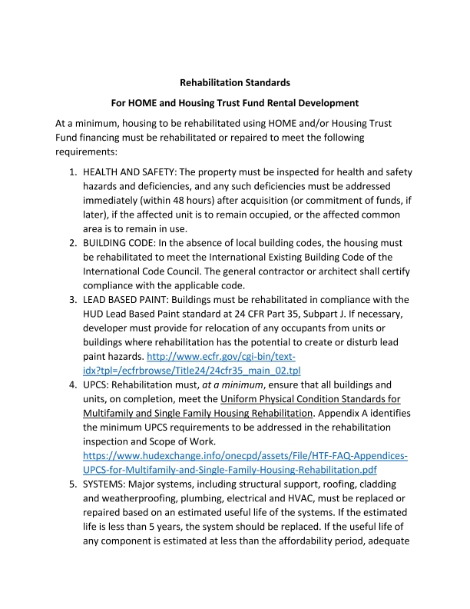
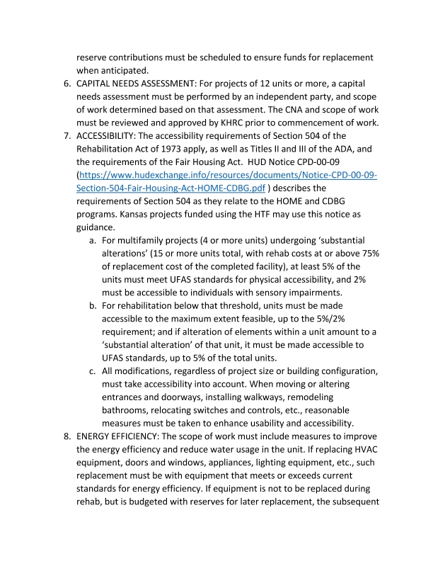
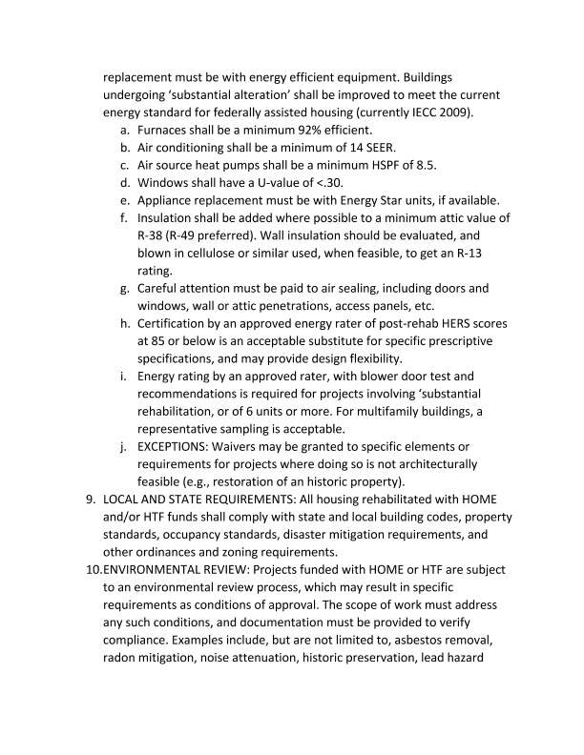
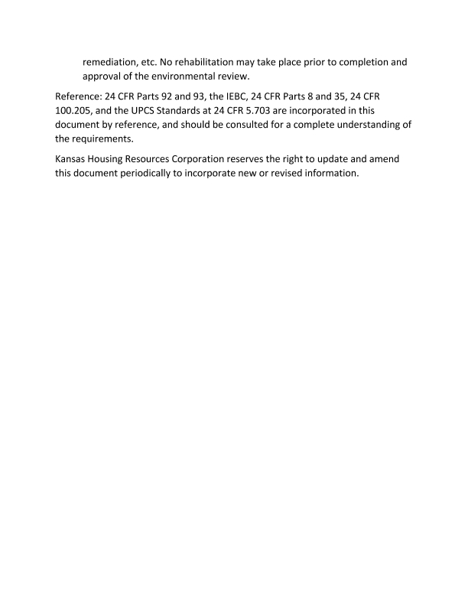
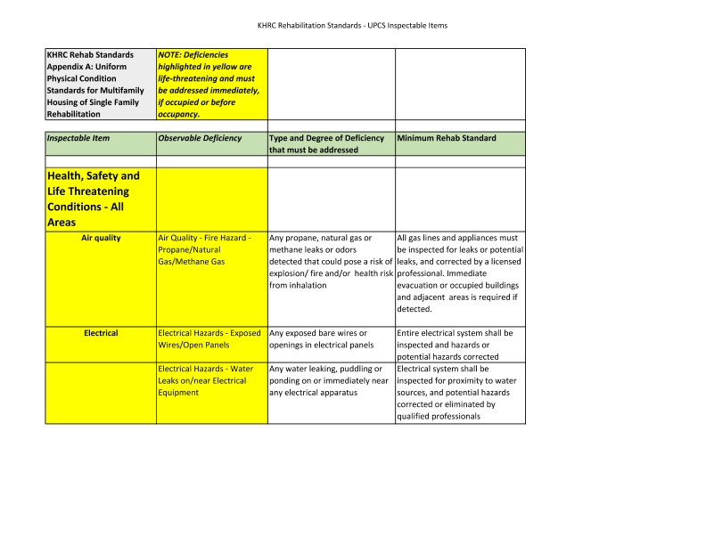
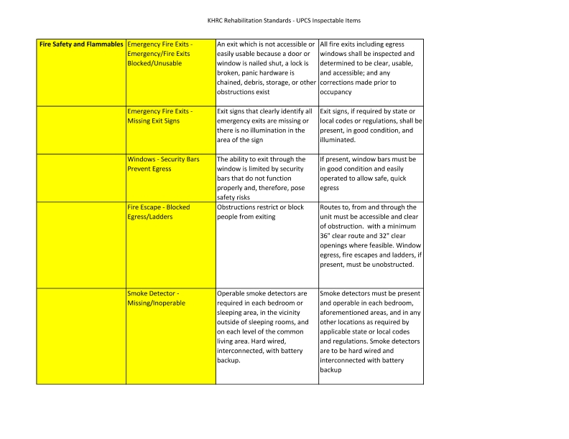
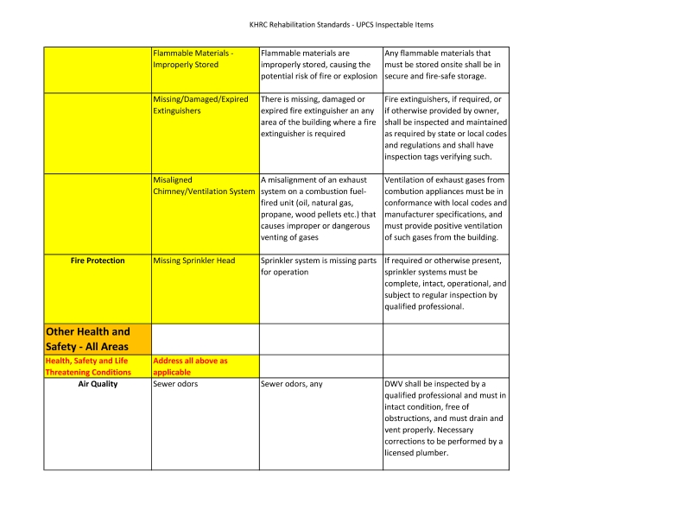
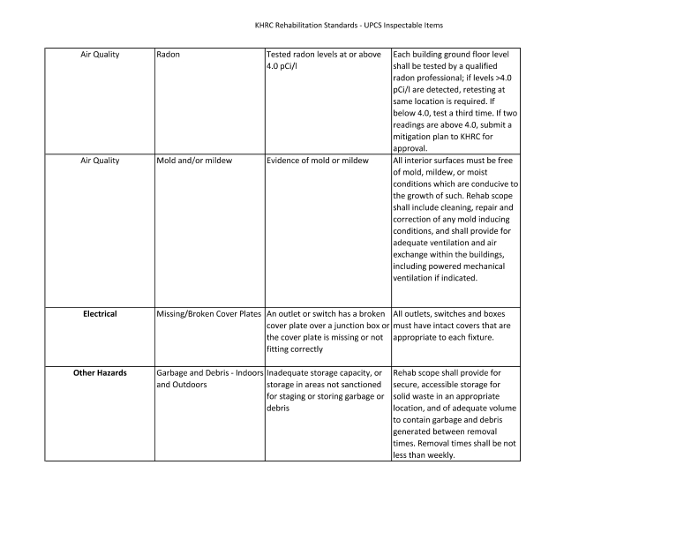
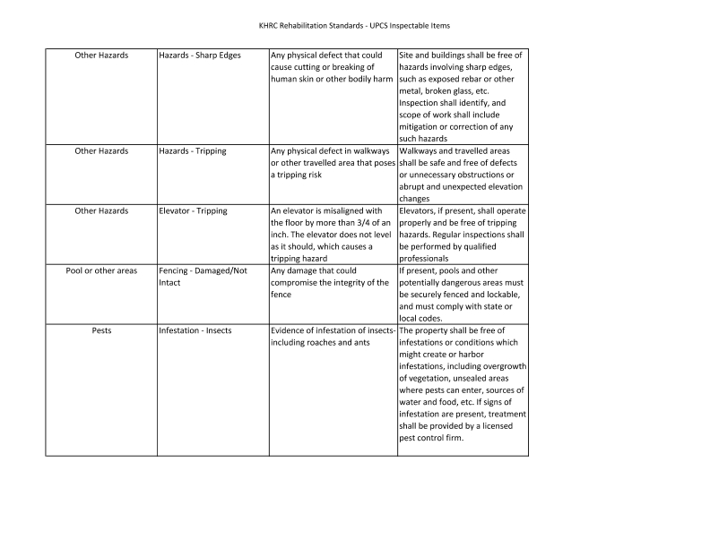
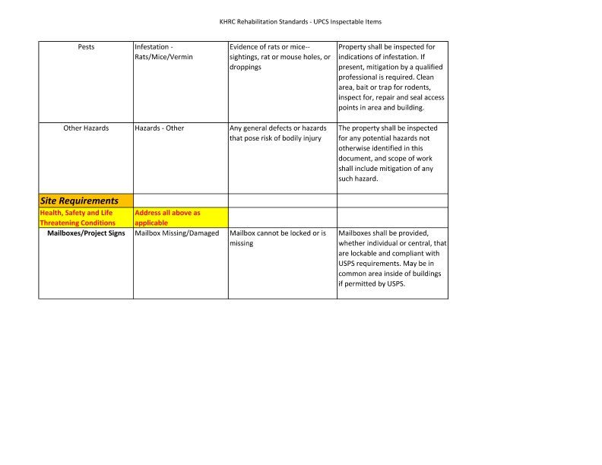
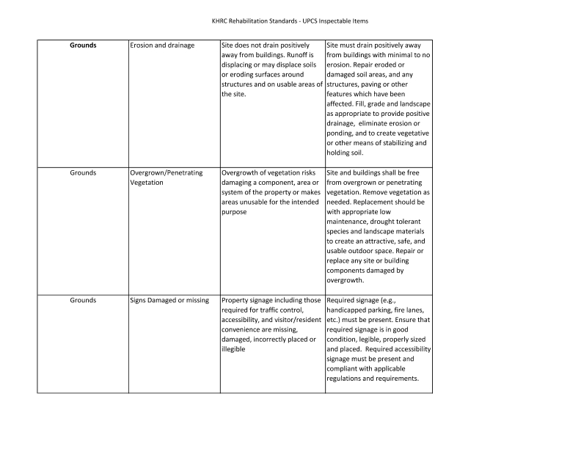
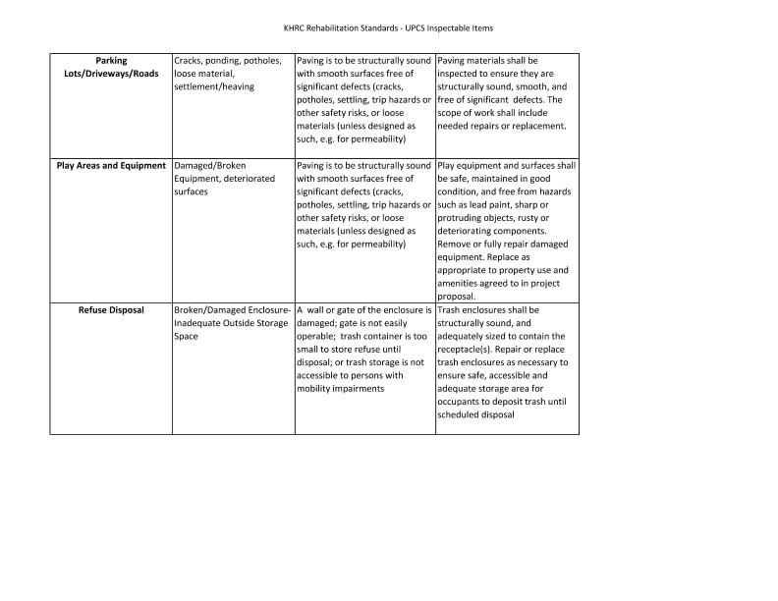
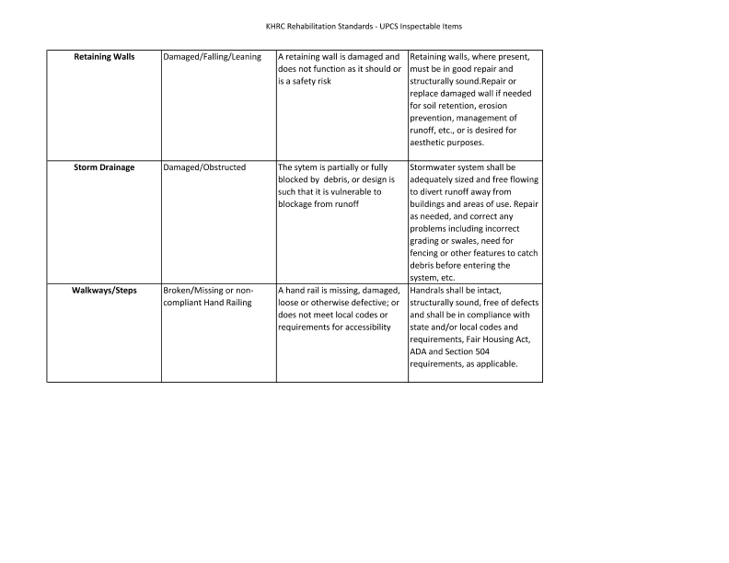
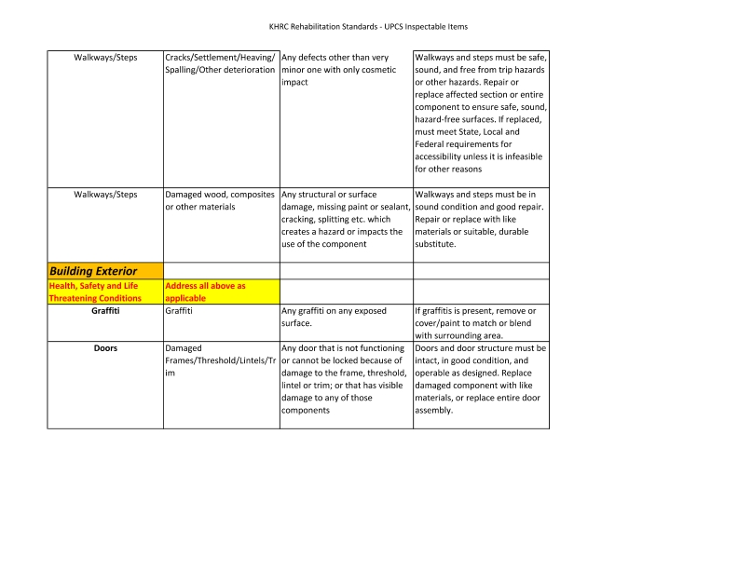
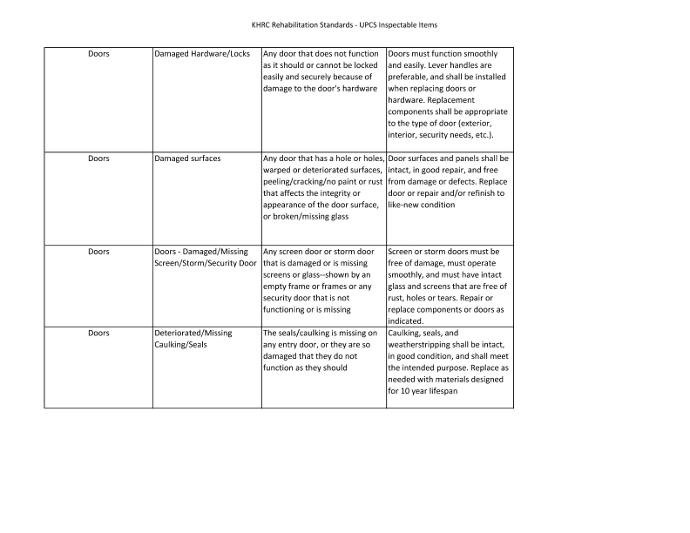
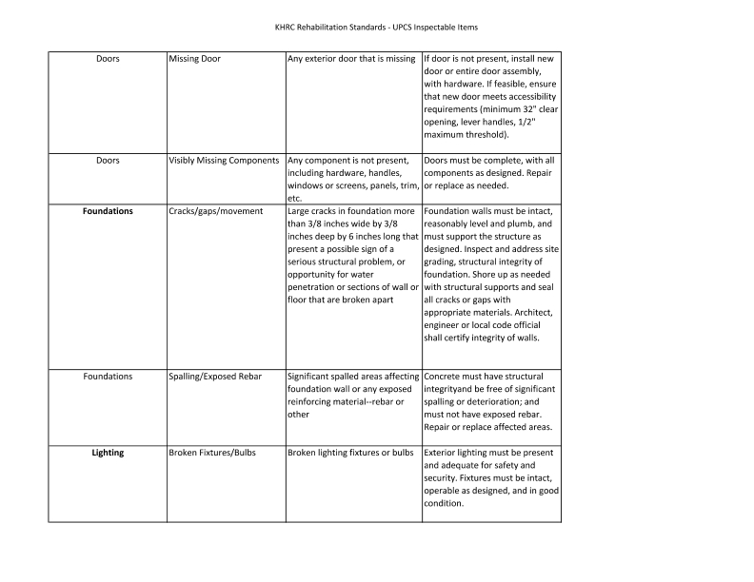
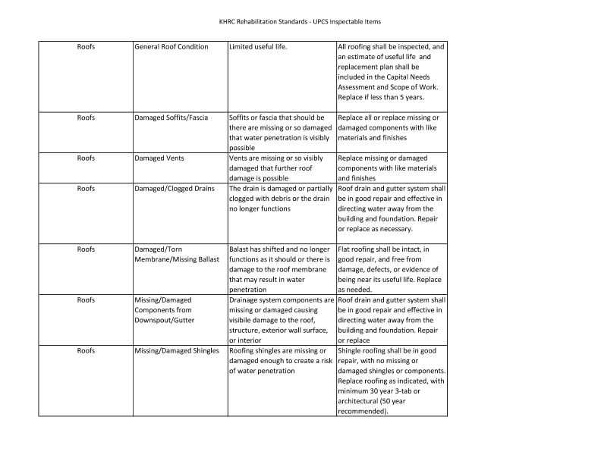
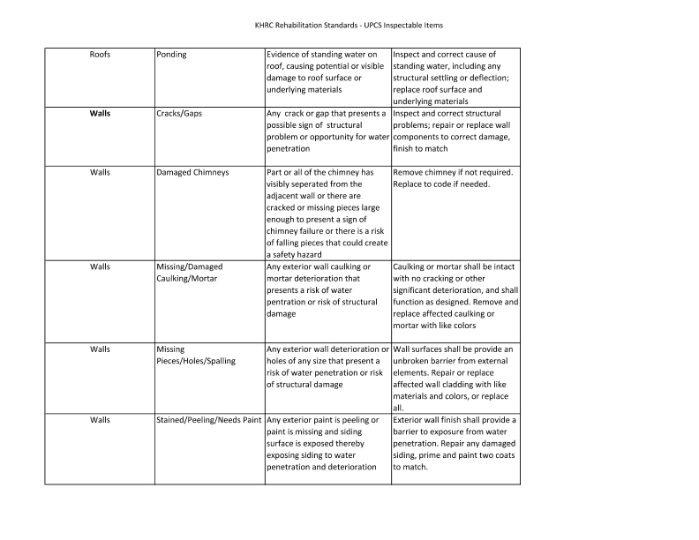
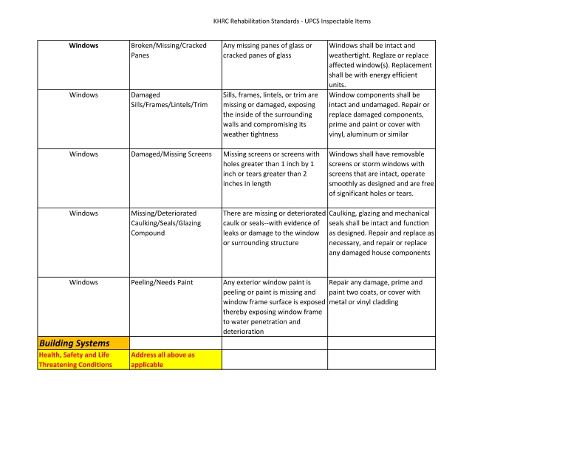
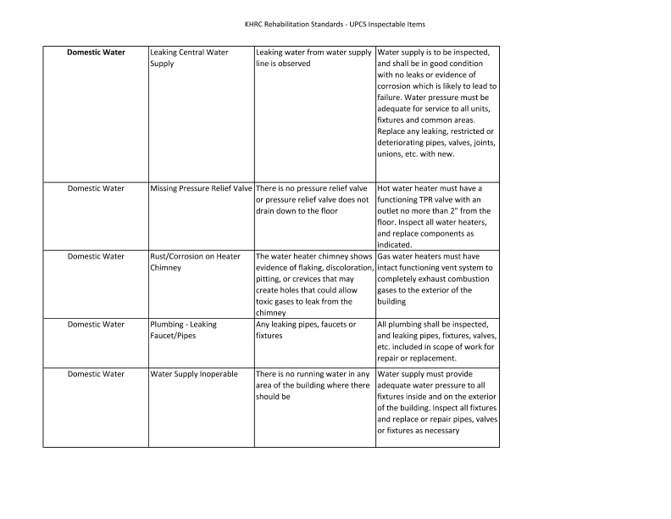
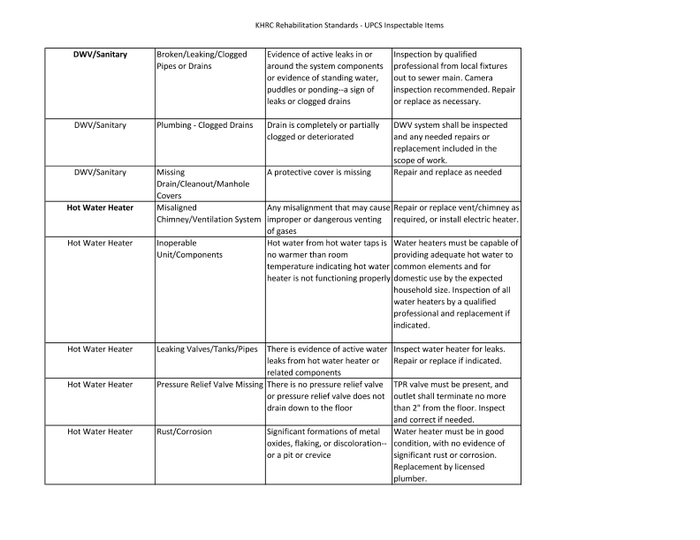
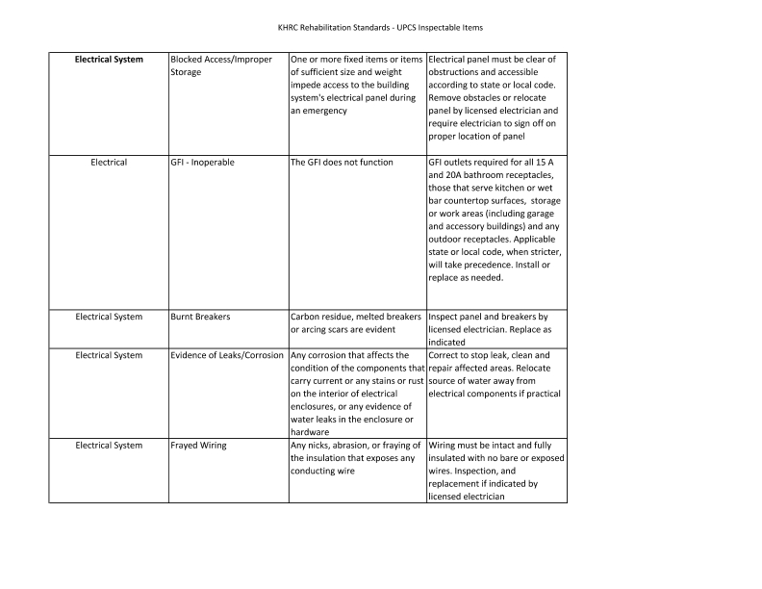
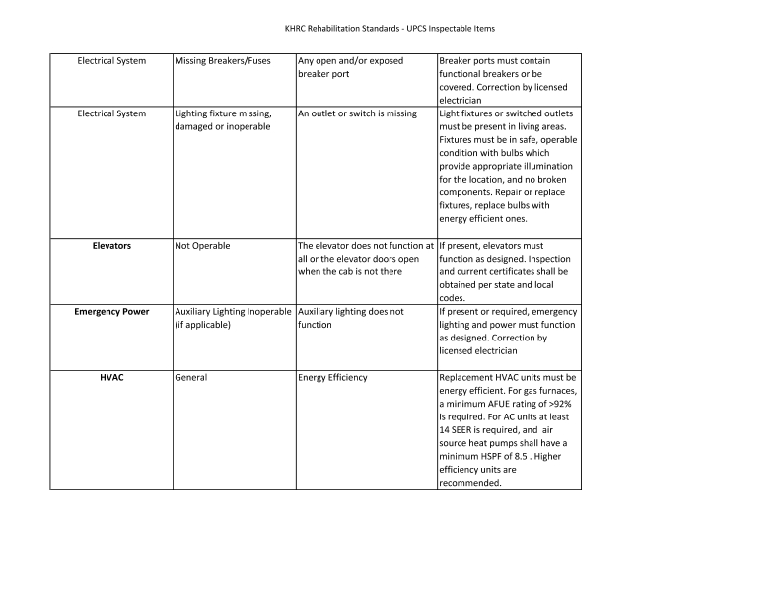
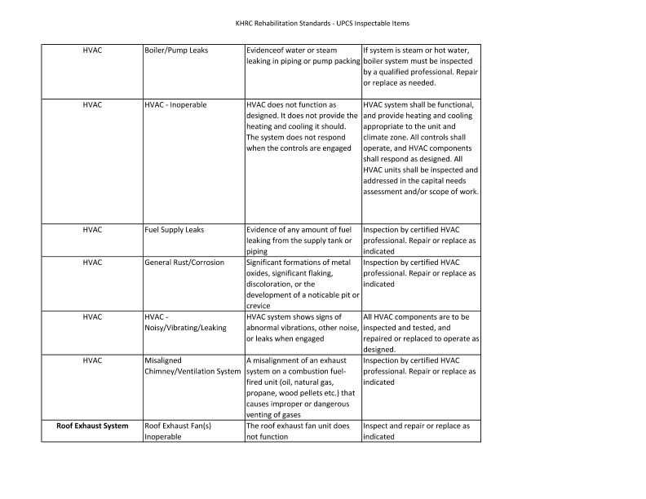
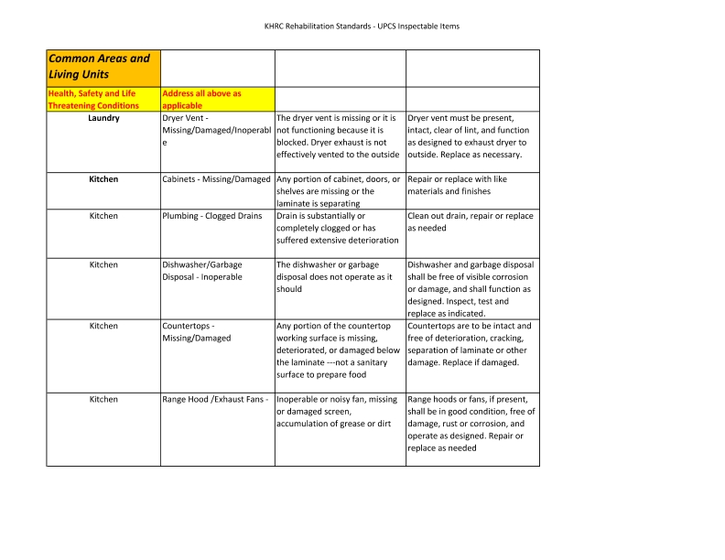
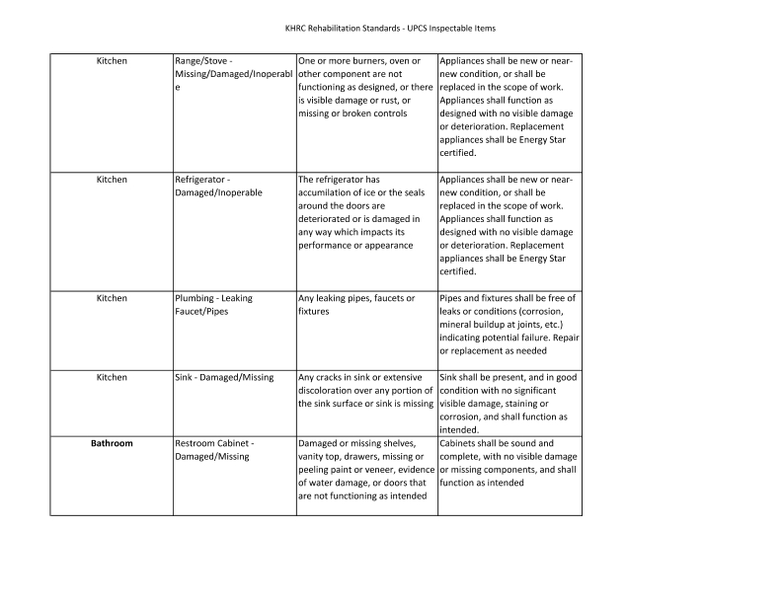
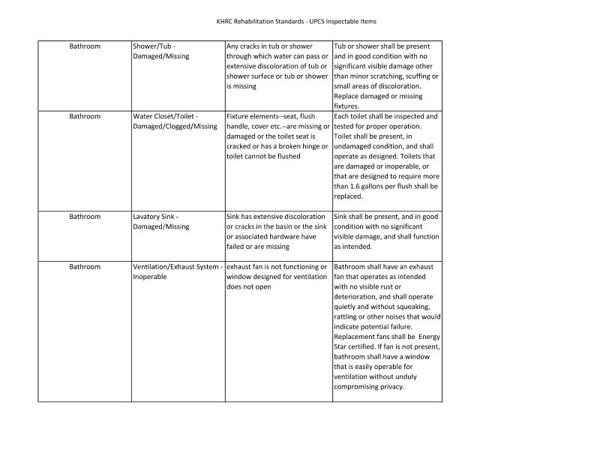
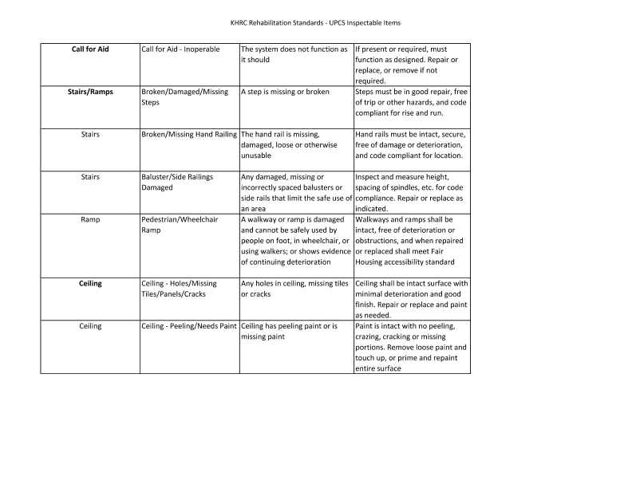
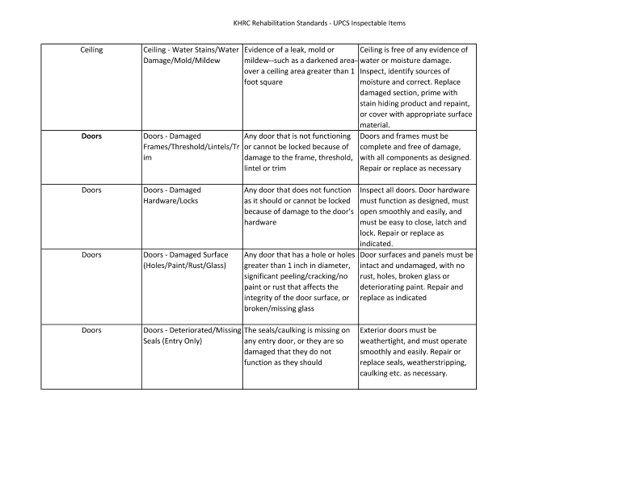
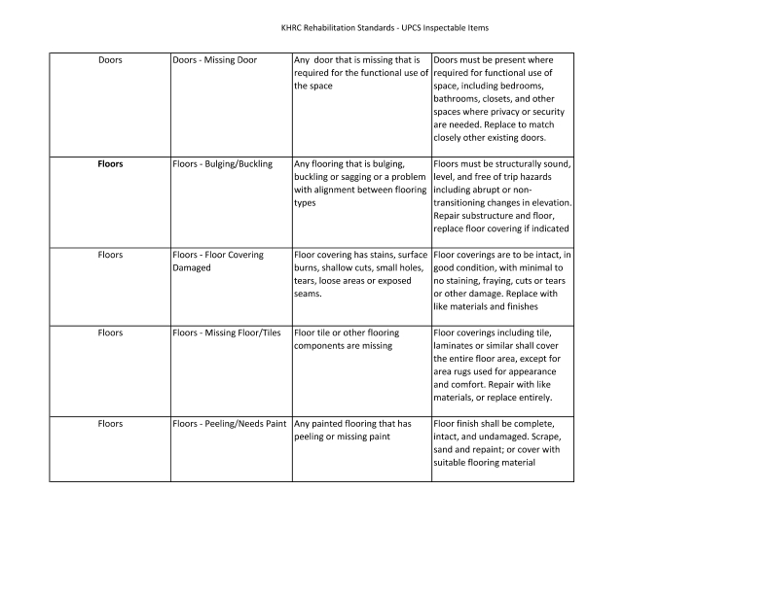
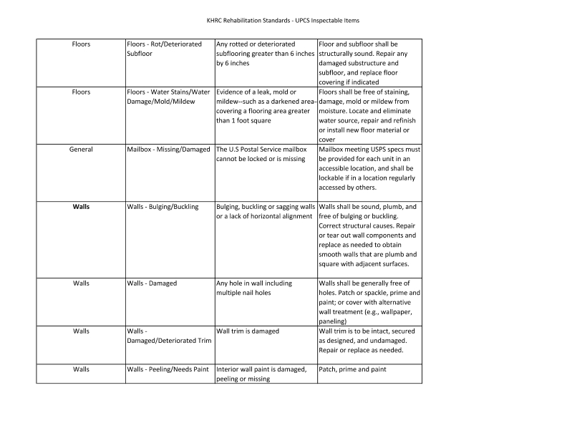
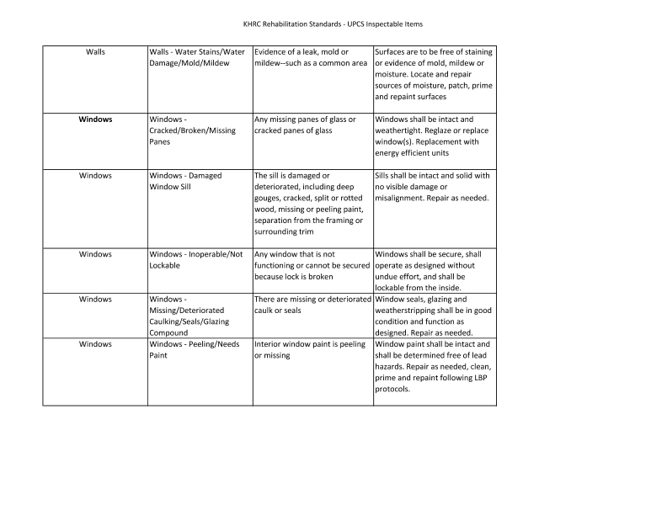
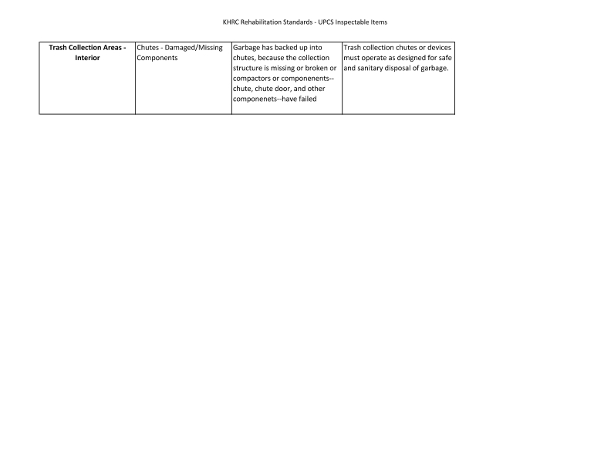
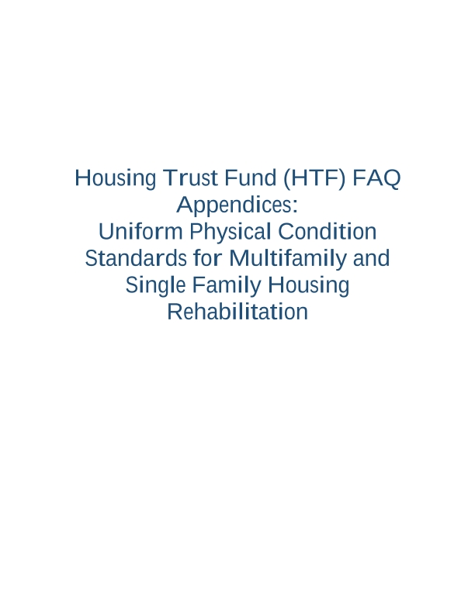
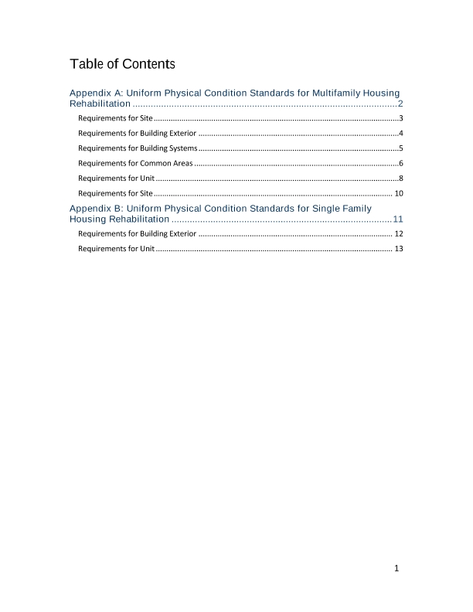
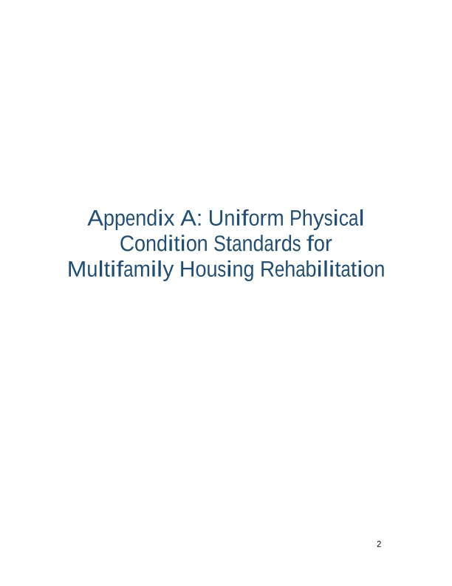
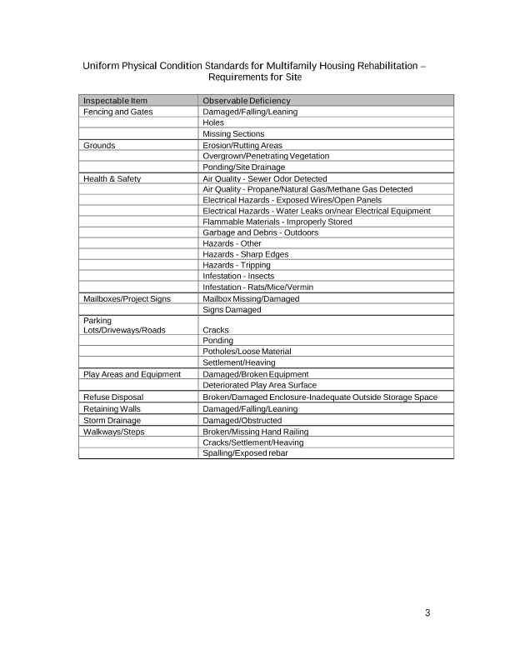
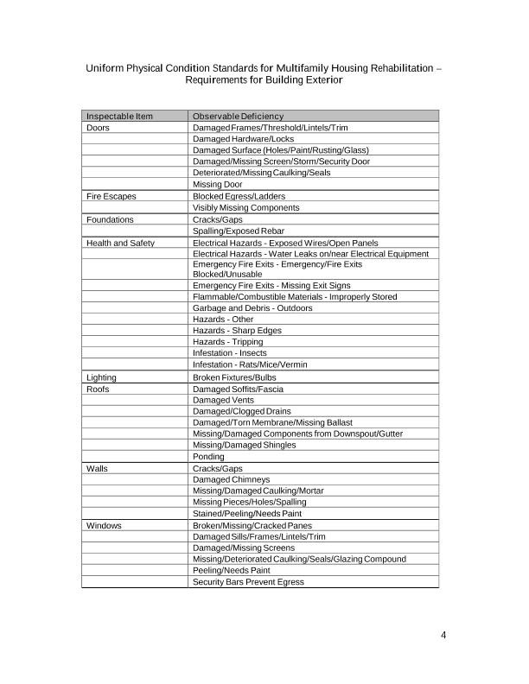
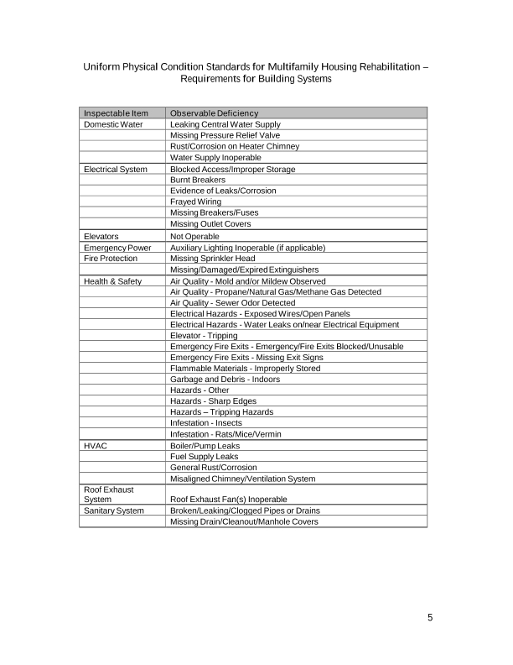
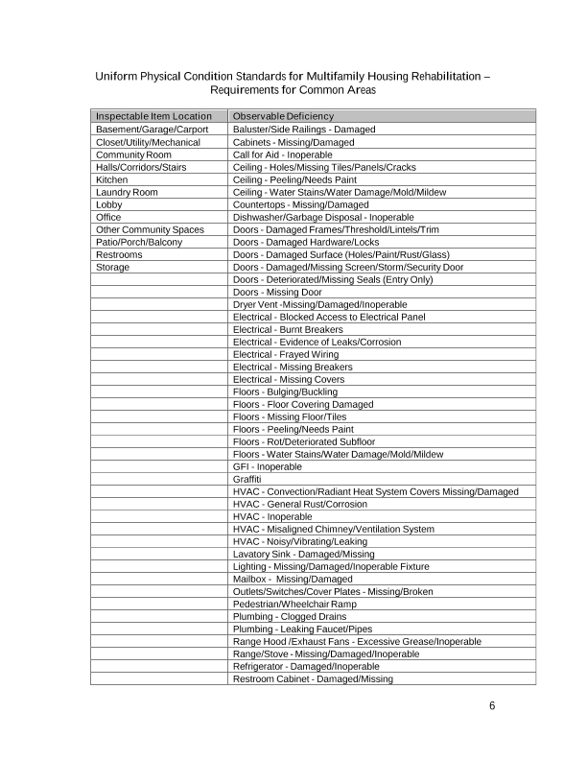
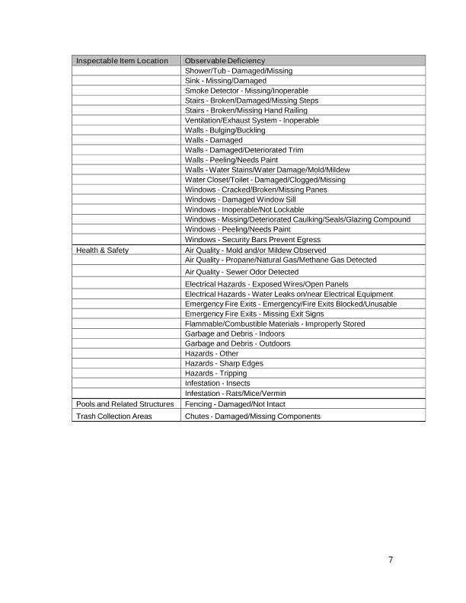
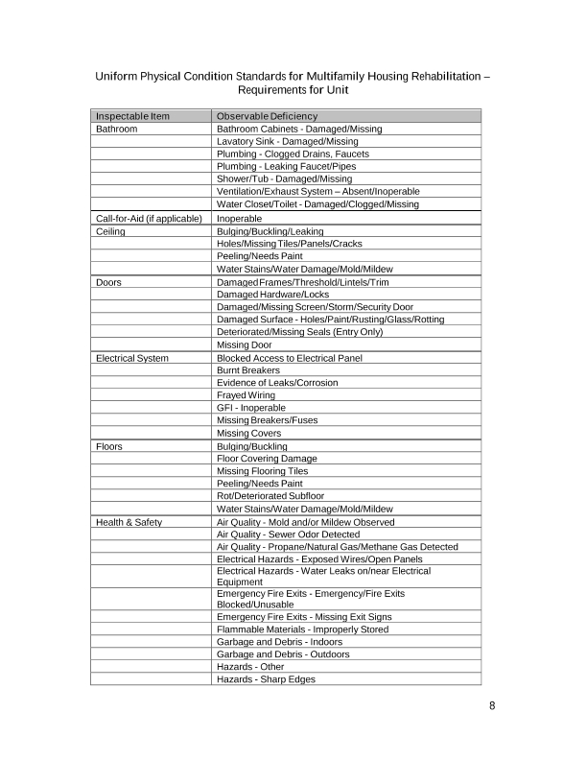
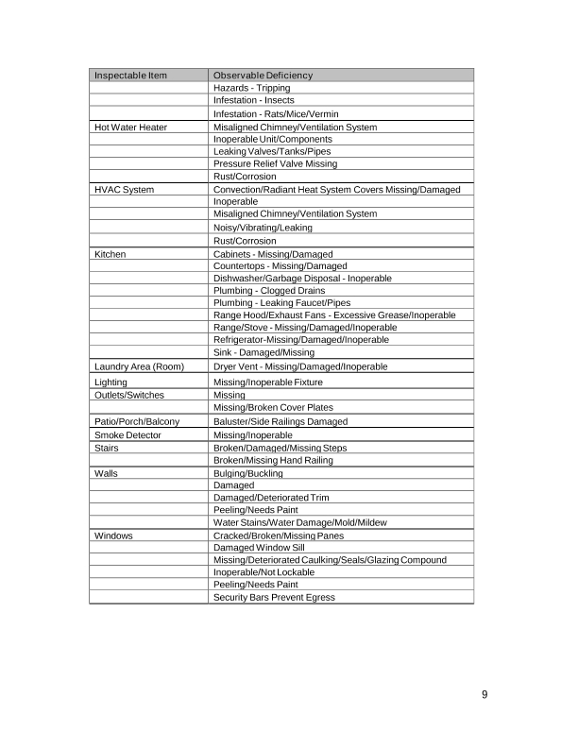
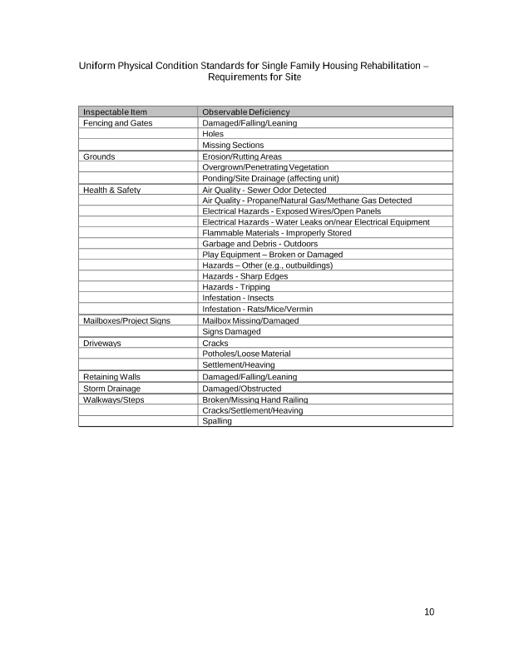
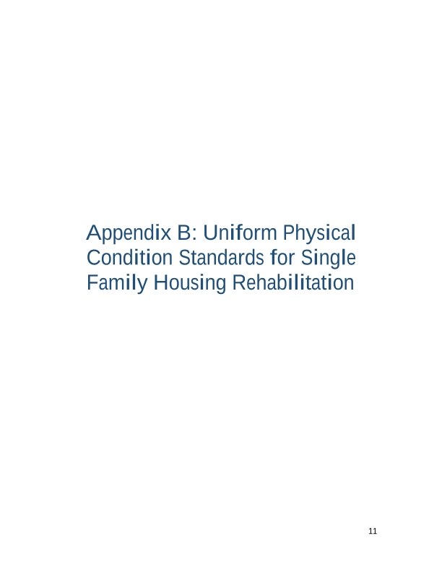
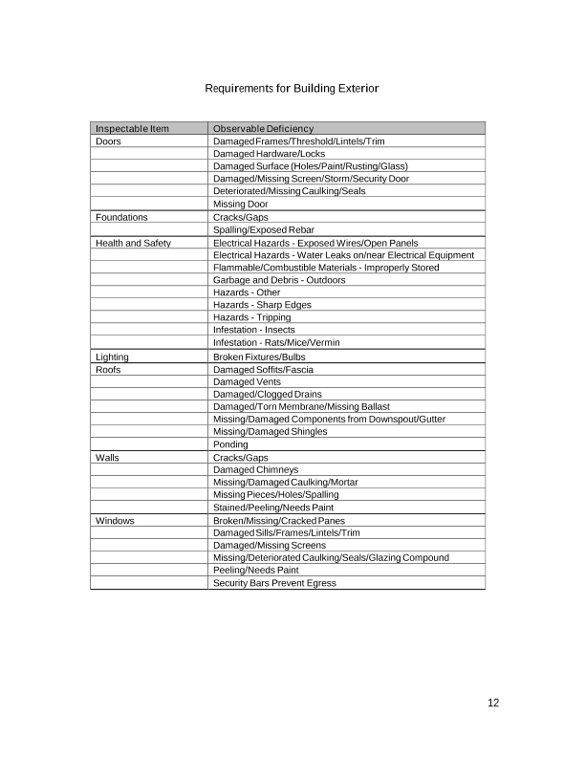
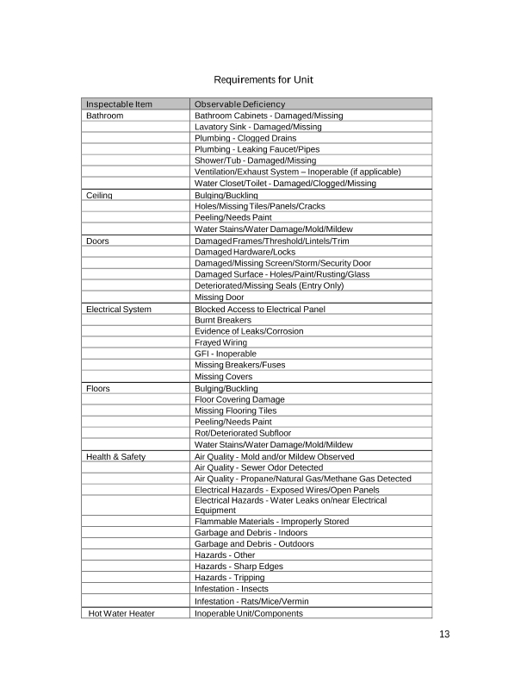
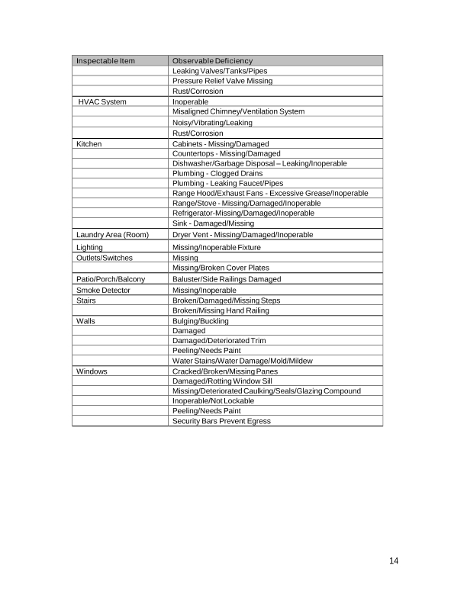
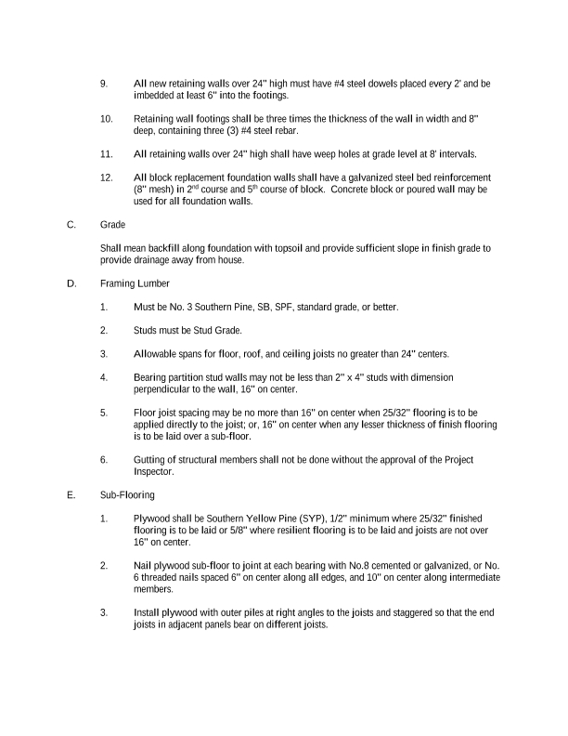
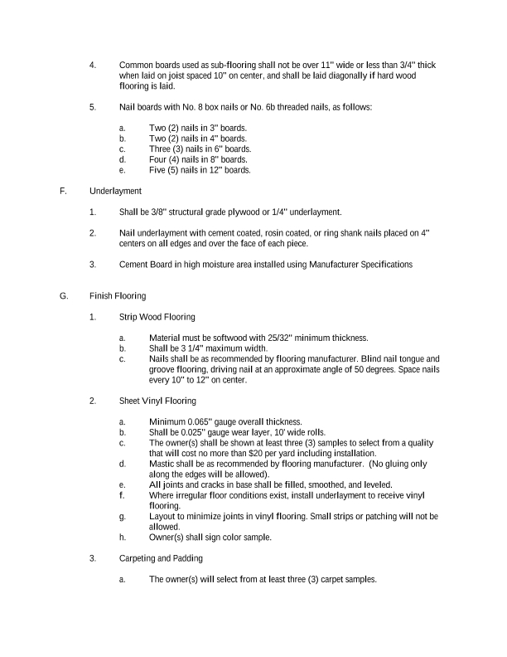
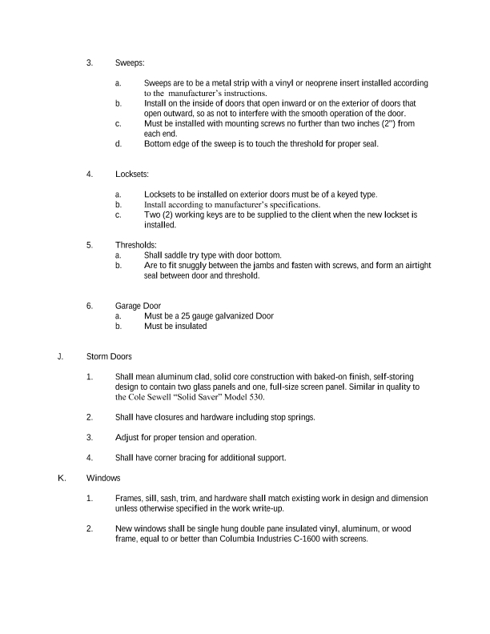
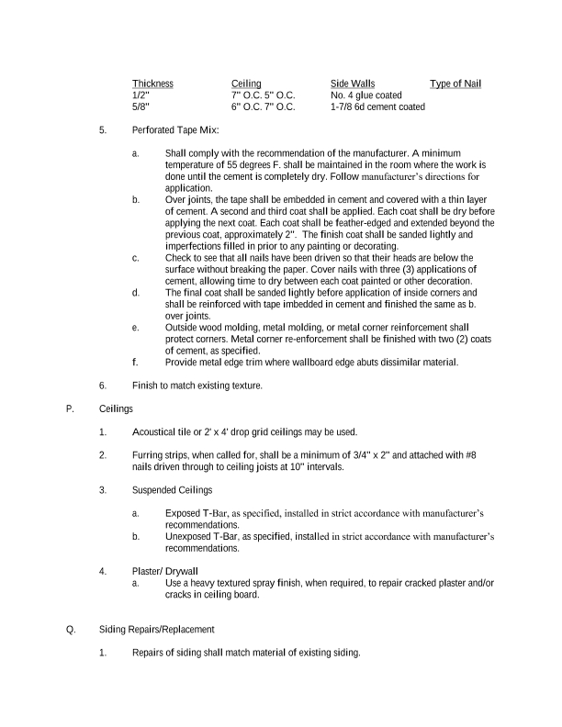
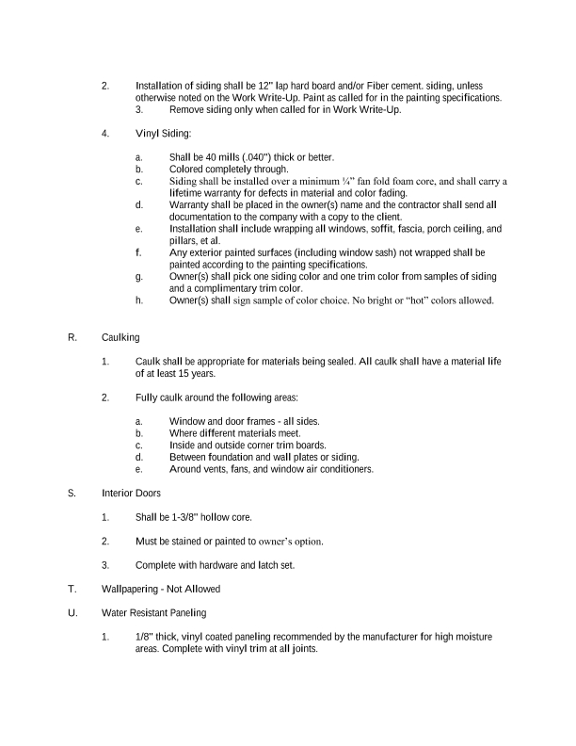
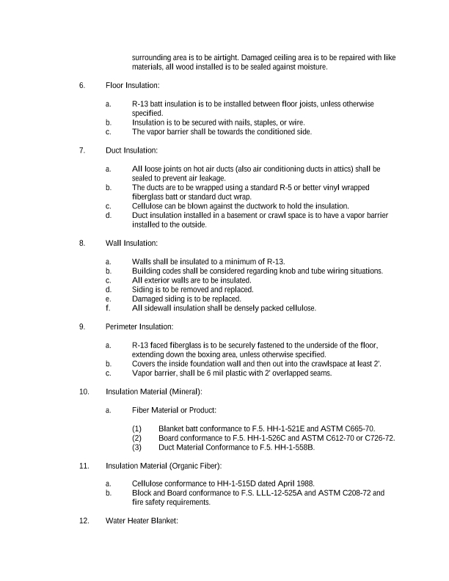
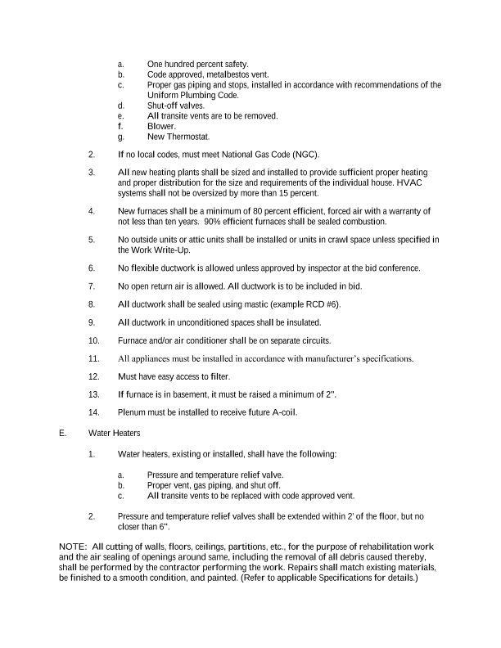
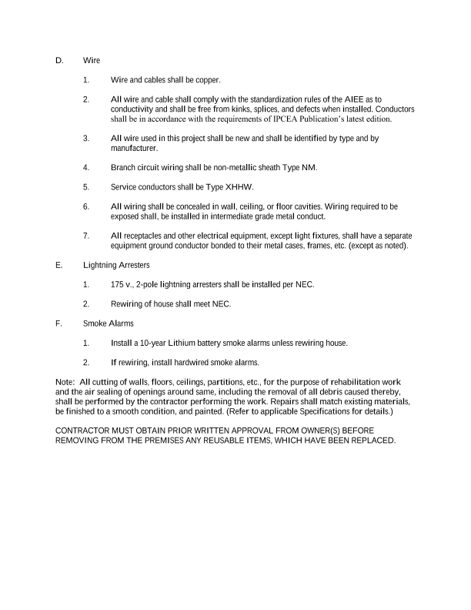
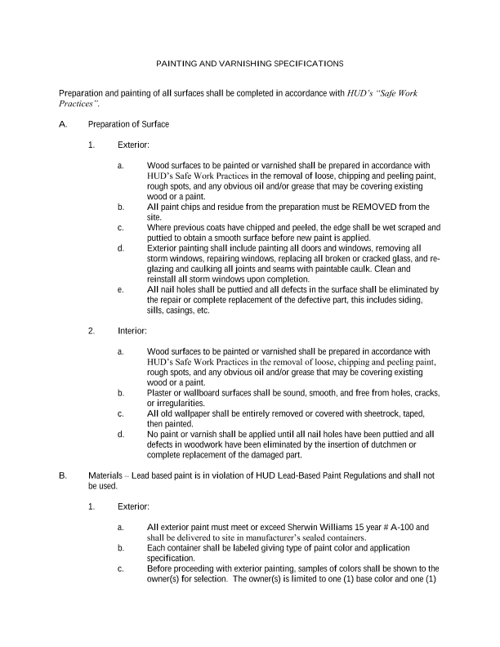
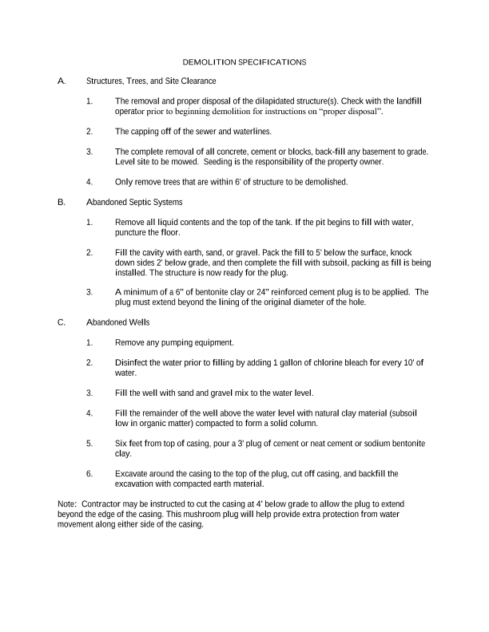
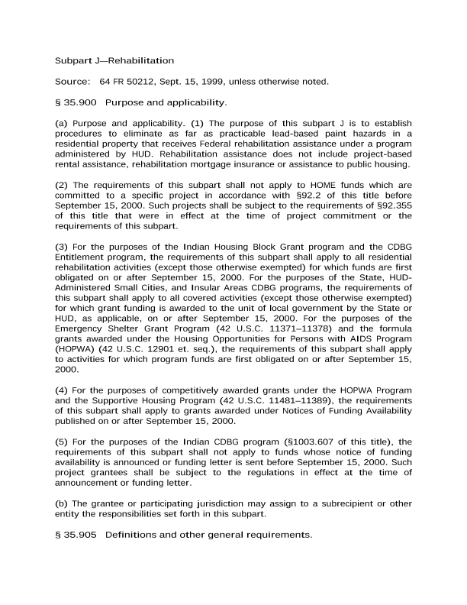
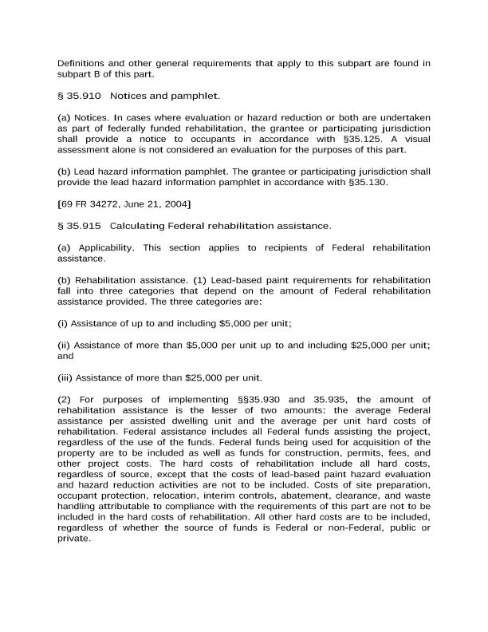
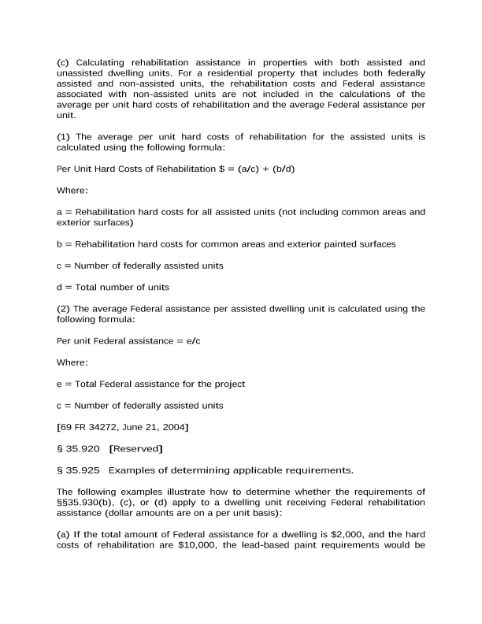
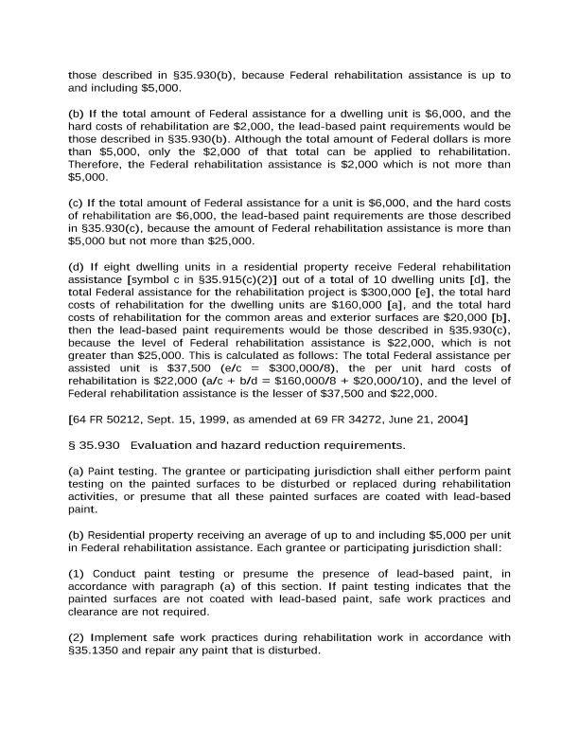
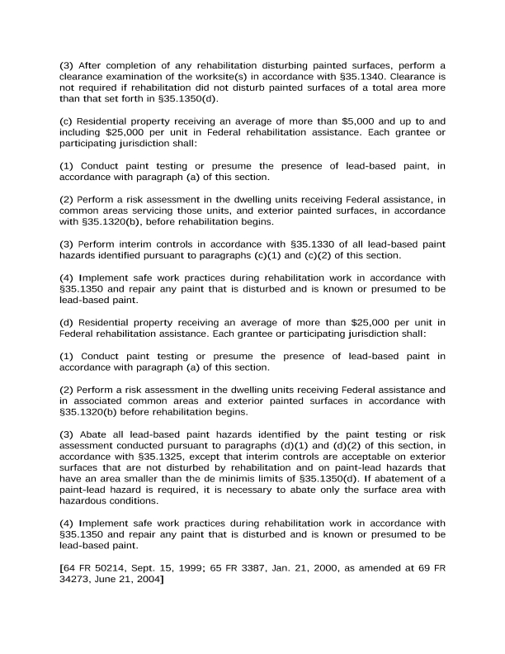
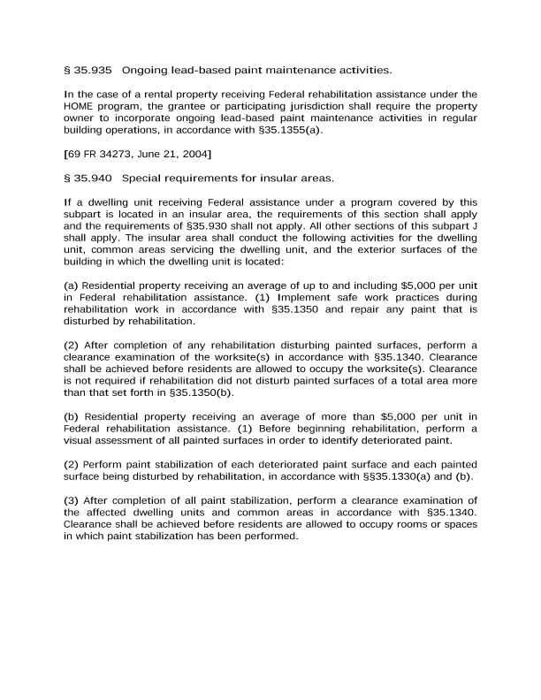

9. Resale or Recapture Guidelines. Below, the grantee must enter (or attach) a description of the guidelines that will be used for resale or recapture of HTF funds when used to assist first-time homebuyers. If the grantee will not use HTF funds to assist first-time homebuyers, enter “N/A”.
N/A

10. HTF Affordable Homeownership Limits. If the grantee intends to use HTF funds for homebuyer assistance and does not use the HTF affordable homeownership limits for the area provided by HUD, it must determine 95 percent of the median area purchase price and set forth the information in accordance with §93.305. If the grantee will not use HTF funds to assist first-time homebuyers, enter “N/A”.
Any limitation or preference must not violate nondiscrimination requirements in § 93.350, and the grantee must not limit or give preferences to students. The grantee may permit rental housing owners to limit tenants or give a preference in accordance with § 93.303(d)(3) only if such limitation or preference is described in the action plan.
Any limitation or preference must not violate nondiscrimination requirements in § 93.350, and the grantee must not limit or give preferences to students. The grantee may permit rental housing owners to limit tenants or give a preference in accordance with § 93.303(d)(3) only if such limitation or preference is described in the action plan.
Developers and owners of HTF-assisted rental housing may limit or give occupancy preference to segments of the population that have been identified as having particular challenges obtaining affordable housing, including but not limited to elderly (as defined by HOPA, the Housing for Older Persons Act), persons with disabilities, homeless families and individuals and victims of domestic violence, provided those limitations or preferences do not violate the nondiscrimination requirements in 24 CFR 93.350. Such limitations or preferences may not extend to students.
12. Refinancing of Existing Debt. Enter or attach the grantee’s refinancing guidelines below. The guidelines describe the conditions under which the grantee will refinance existing debt. The grantee’s refinancing guidelines must, at minimum, demonstrate that rehabilitation is the primary eligible activity and ensure that this requirement is met by establishing a minimum level of rehabilitation per unit or a required ratio between rehabilitation and refinancing. If the grantee will not refinance existing debt, enter “N/A.”
N/A

Discussion:

Attachments

