The Kansas Housing Resources Corporation hereby agrees to provide its own funds for the downpayment assistance (DPA) loan as stated below in connection with the associated first mortgage and has a legally enforceable obligation to provide those DPA funds.

Lender must place this form, the DPA note, and the DPA mortgage on the right side of the endorsement binder with Asset Verification documentation needed to close.

Commitment Date Estimated Closing Date KHRC Loan Number

Lender Name

HOME Investment Partnerships Program
DPA Program |  | DPA Loan Amount

Borrower Name |  | Co-Borrower Name

Property Address |  | City

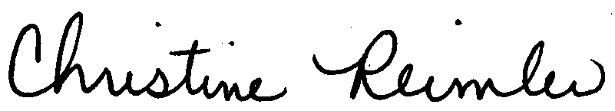
Christine Reimler
Director, HOME Program

